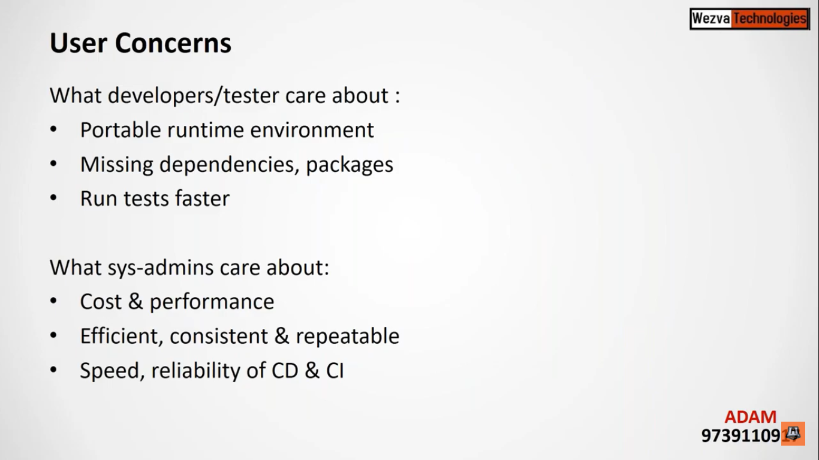

Containers are nothing but empty box in which whatever you put will be sealed and isolated from other containers.

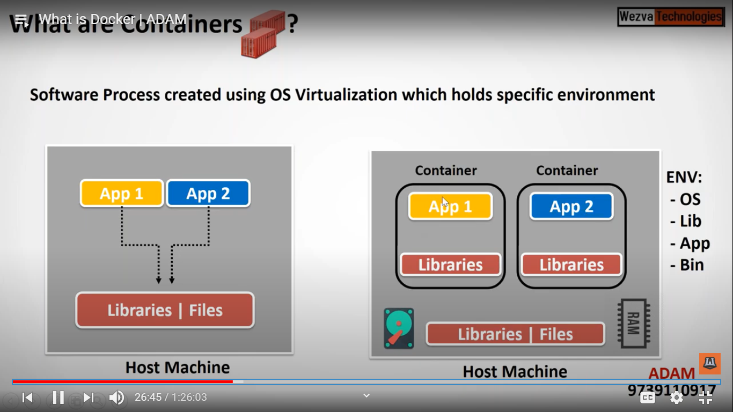

Container is nothing but a process which will be created virtually.

But here also if we have 2 containers and both are sharing 4gb of Ram each and we have 12 gb of RAM so maximum we can create 2 containers in this hostname.

Each container will have only one OS in it

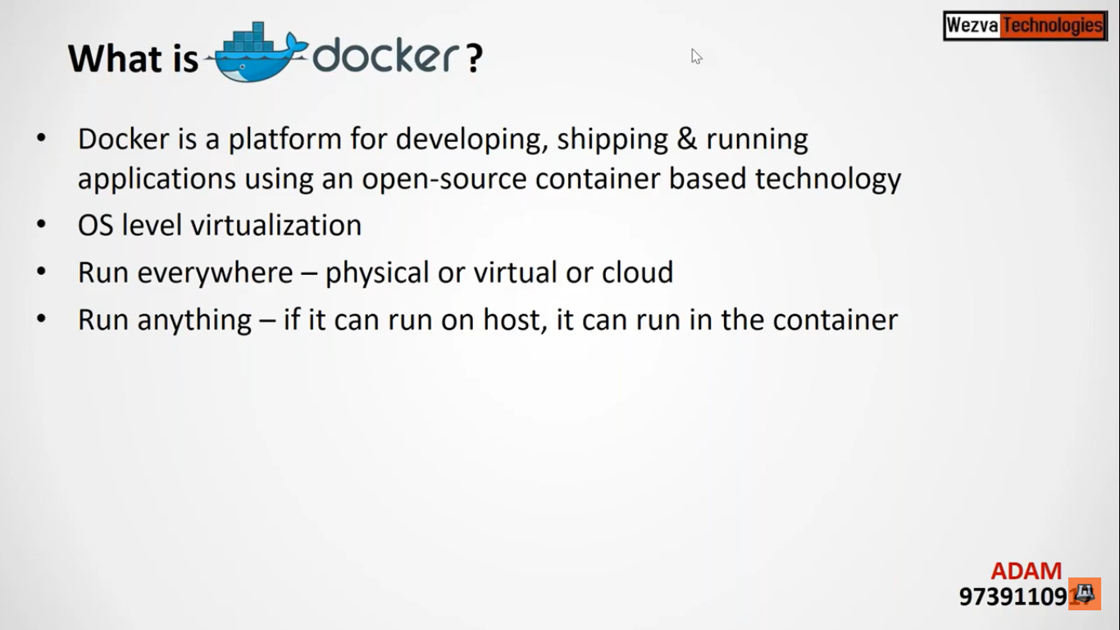

Docker is a tool to help create containers.

For creating a container you don’t need to allocate any RAM

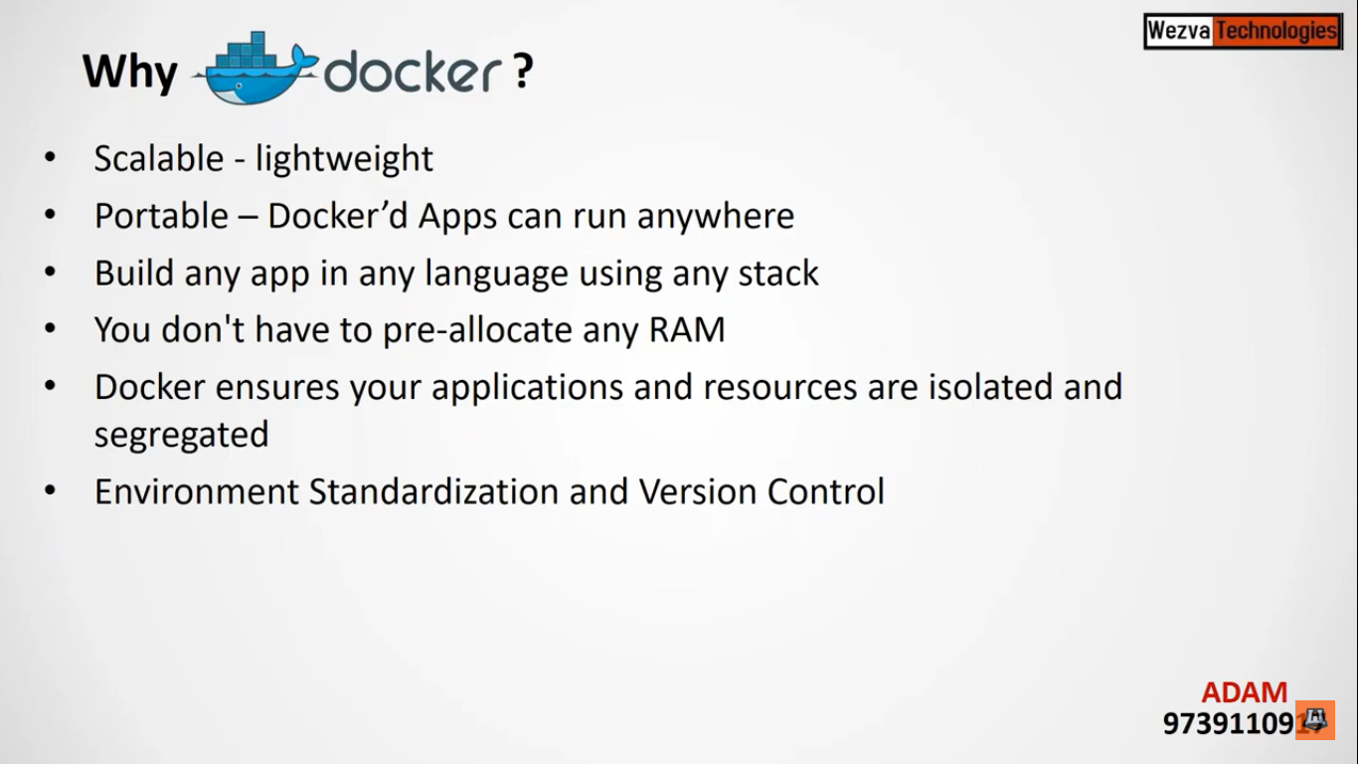

Difference between Virtualisation and Containers.

While creating VM you will be required to allocate atleast some RAM i.e. minimum of 1 GB

But in case of containers since it is a empty box here we don’t require any Ram to create a container unless you are running any application in it.

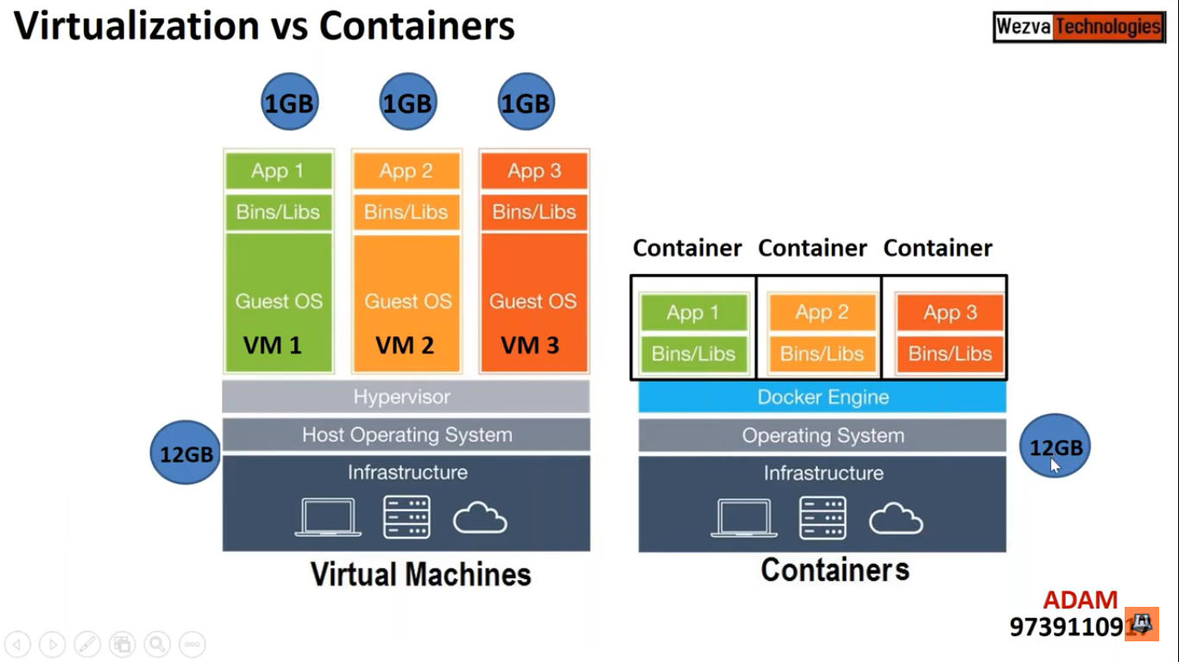

The default behavior of container is that it will consume whatever amount of RAM is available in the host machine

But Docker will have control on how much resource a container can take from the host machine.

Component of Dockers

When we are creating any container using Docker, it will create daemon and CLI.

Daemon is nothing but a process which will be running behind without any user interactions.

To connect to the daemon, we will be using command line to connect it.

And for environment purpose we will be required image, which will have collection of files required for specific OS.

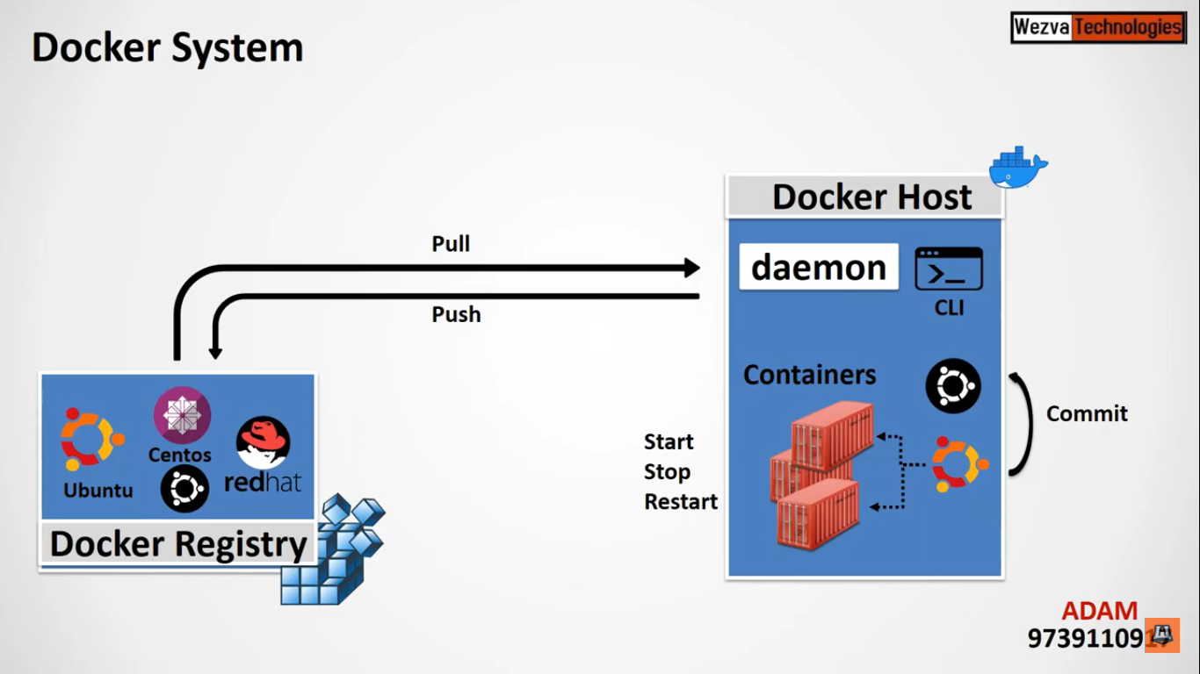

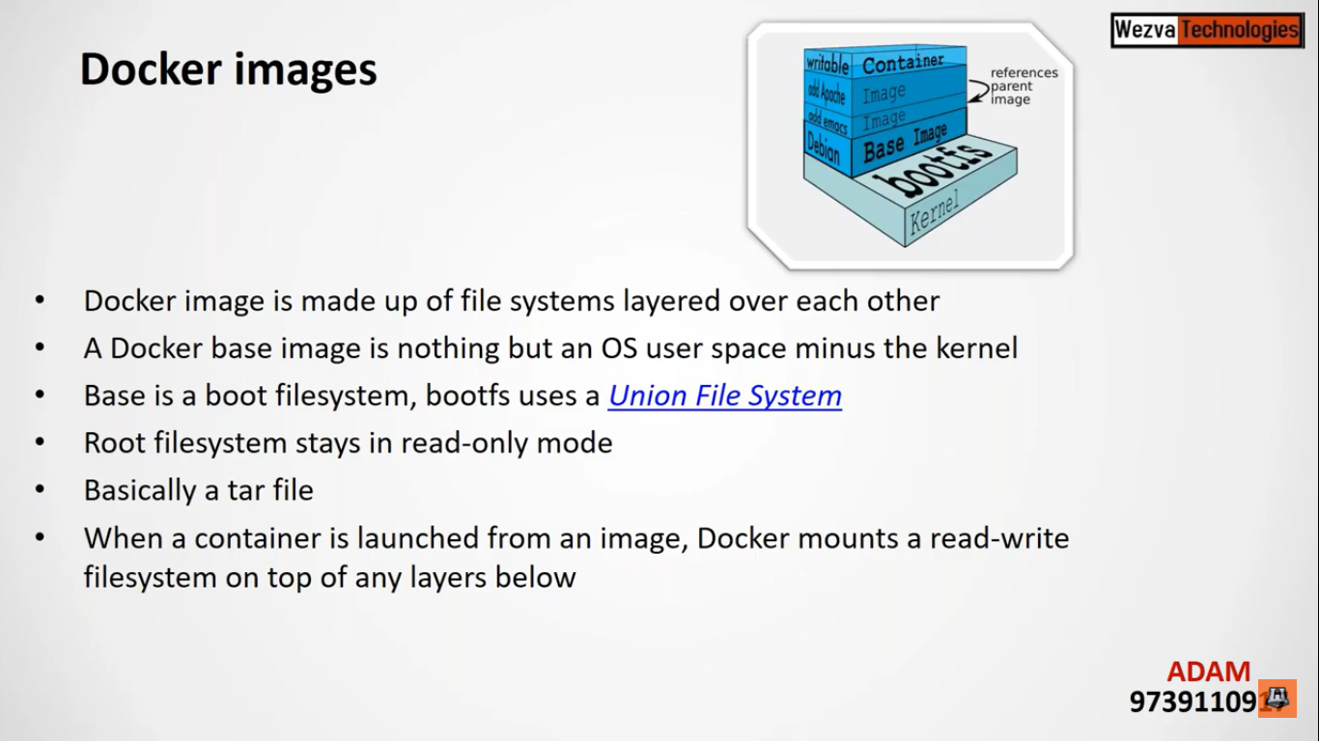

In Docker image it will have all things which will required for specific OS but it wont have kernel in it so it won’t allocate a RAM if nothing is running in it

Image is a layer of file system.

Image is read only.

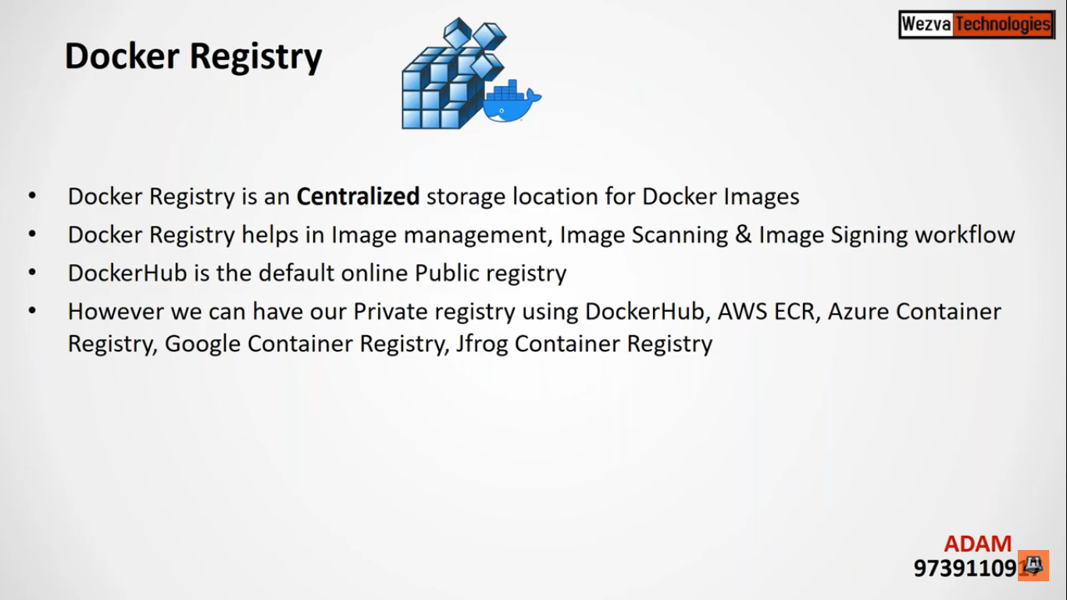

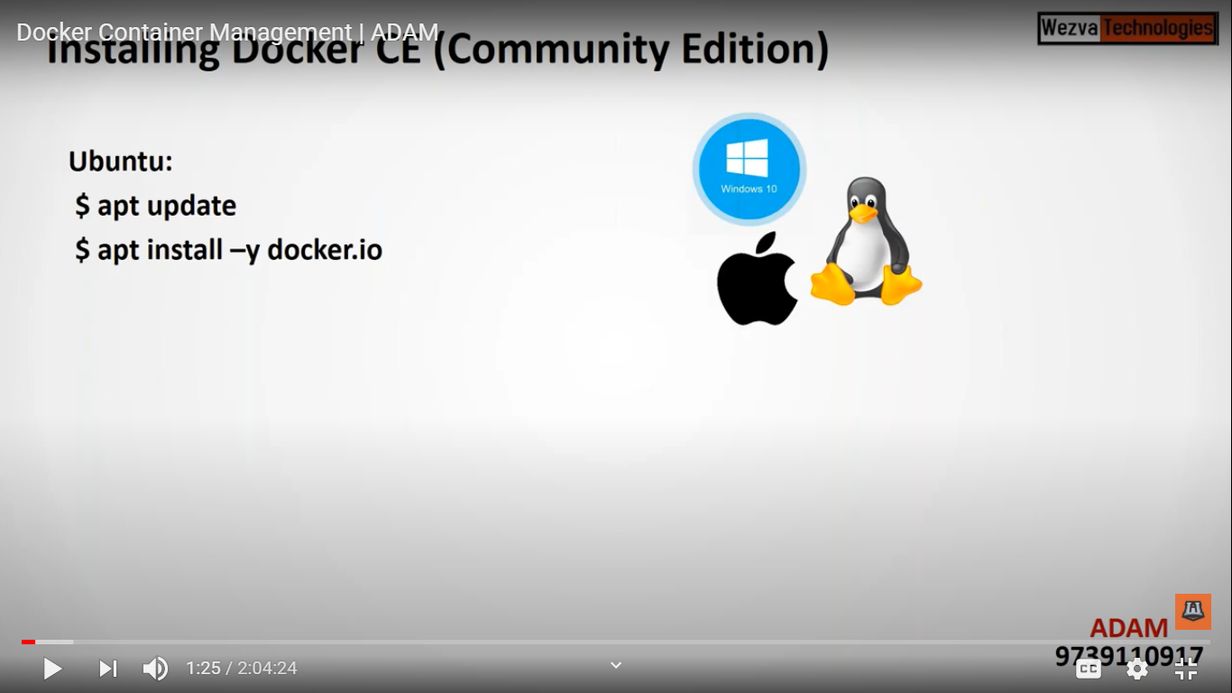

To check either docker daemon is running or not we will use below commands

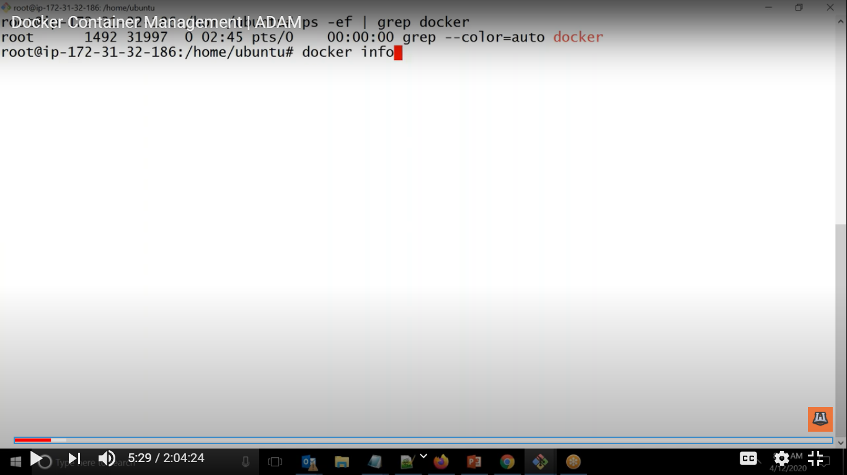

root@ip-172-31-45-217:/home/ubuntu# ps aux | grep docker

root 3696 0.1 8.4 757364 85064 ? Ssl 04:35 0:00 /usr/bin/dockerd -H fd:// --containerd=/run/containerd/containerd.sock

root 3878 0.0 0.1 14852 1076 pts/0 S+ 04:37 0:00 grep --color=auto docker

root@ip-172-31-45-217:/home/ubuntu#

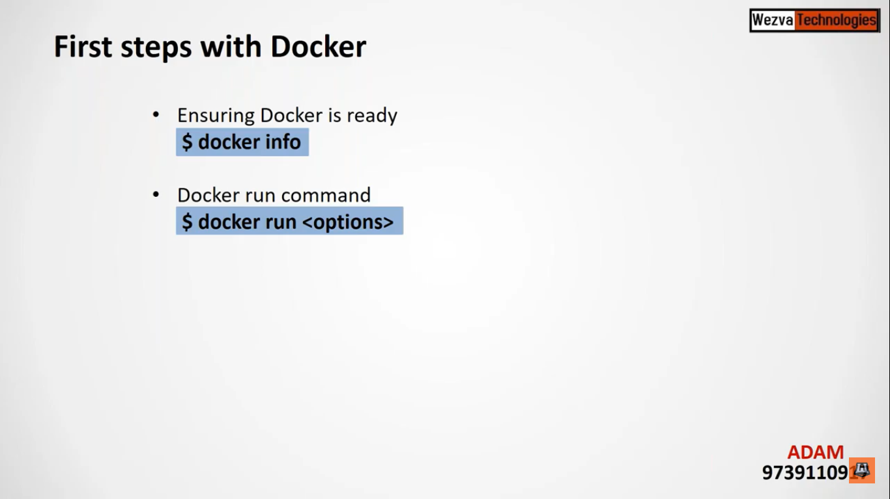

Whenever we are giving docker run every time it will create a new container and the image name which will we give first it will search the image in local host if it is not there it will go to the registry download it and create the container using it.

Below are the steps which will be done whenever docker run command is being executed

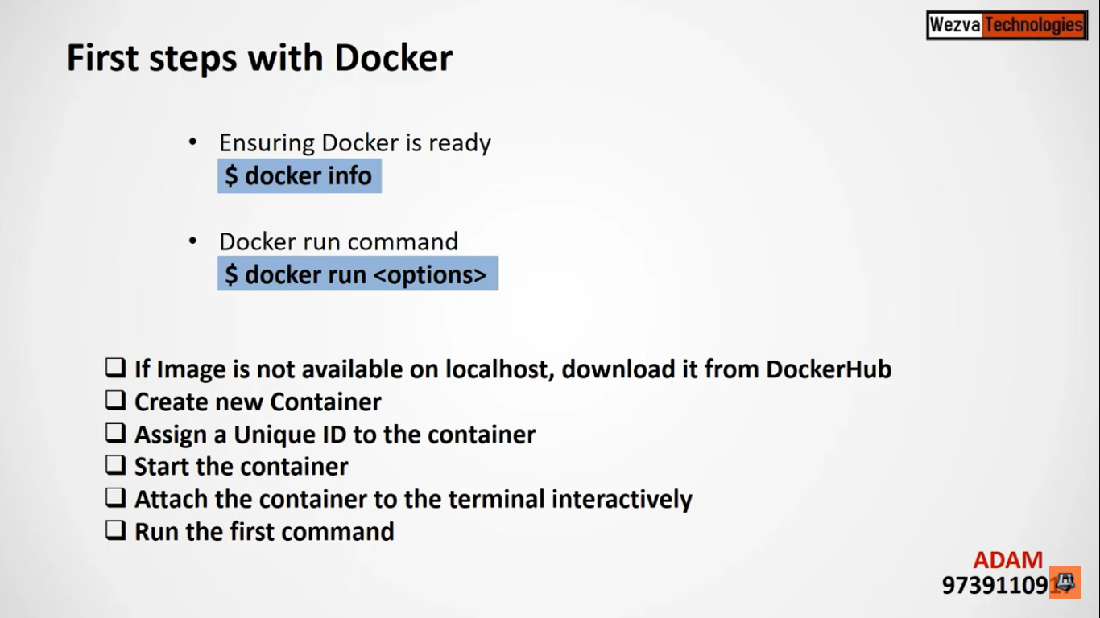

When to use VM and when to use Container

Whenever whole lot of work which we will be day to day work then VM will be required.

But sometimes when different environment is required that time we can create container and sometimes we required multiple copies of image

Docker attach means attach the terminal to the container

root@ip-172-31-45-217:/home/ubuntu# docker run -it centos

Unable to find image 'centos:latest' locally

latest: Pulling from library/centos

3c72a8ed6814: Pull complete

Digest: sha256:76d24f3ba3317fa945743bb3746fbaf3a0b752f10b10376960de01da70685fbd

Status: Downloaded newer image for centos:latest

[root@b1582664944c /]# hostname

b1582664944c

Here we can see that first it downloaded the images then attach the terminal in interative way that is why hostname got changed here

Now we are inside the container

[root@b1582664944c /]# cat /etc/os-release

NAME="CentOS Linux"

VERSION="8 (Core)"

ID="centos"

ID_LIKE="rhel fedora"

VERSION_ID="8"

PLATFORM_ID="platform:el8"

PRETTY_NAME="CentOS Linux 8 (Core)"

ANSI_COLOR="0;31"

CPE_NAME="cpe:/o:centos:centos:8"

HOME_URL="https://www.centos.org/"

BUG_REPORT_URL="https://bugs.centos.org/"

CENTOS_MANTISBT_PROJECT="CentOS-8"

CENTOS_MANTISBT_PROJECT_VERSION="8"

REDHAT_SUPPORT_PRODUCT="centos"

REDHAT_SUPPORT_PRODUCT_VERSION="8"

Ram will be used from host machine only

[root@b1582664944c /]# df -kh .

Filesystem Size Used Avail Use% Mounted on

overlay 7.7G 1.8G 6.0G 23% /

[root@b1582664944c /]#

For coming out of the container we will be using exit

If we run docker run again this time it will not download the images as it is already available.

We can give the first command as well while creating the container.

D

docker run -it centos /bin/sh

See below we can give our own first command while creating container.

root@ip-172-31-45-217:/home/ubuntu# docker run -it centos

[root@dcb96984c09f /]# ps -ef

UID PID PPID C STIME TTY TIME CMD

root 1 0 7 06:01 pts/0 00:00:00 /bin/bash

root 14 1 0 06:02 pts/0 00:00:00 ps -ef

[root@dcb96984c09f /]# exit

exit

**root@ip-172-31-45-217:/home/ubuntu# docker run -it centos /bin/sh**

sh-4.4# ps -ef

UID PID PPID C STIME TTY TIME CMD

root 1 0 7 06:02 pts/0 00:00:00 /bin/sh

root 6 1 0 06:02 pts/0 00:00:00 ps -ef

If we are working in organization then we have to give registry name while creating the container.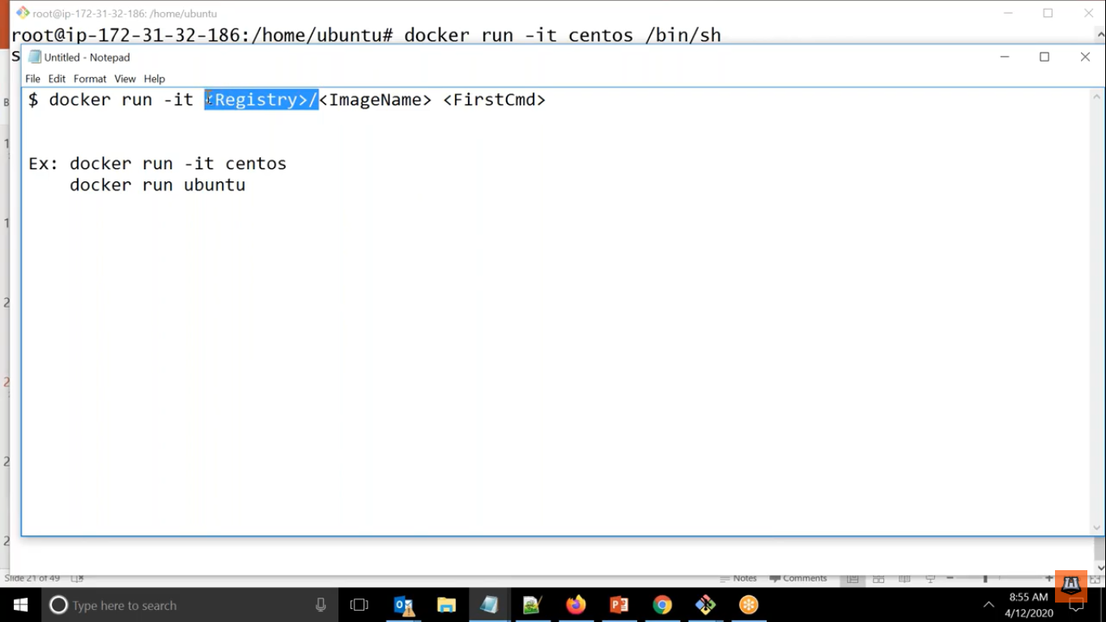

Docker run -it <Registry><ImageName> <FirstCmd>

Here since we are not providing any registry so by default it will pick docker hub as registry.

If Nothing is running in container it will go into stop mode.

If we want to see all the container which are in running state then use

Docker ps

root@ip-172-31-45-217:/home/ubuntu# docker ps

CONTAINER ID IMAGE COMMAND CREATED STATUS PORTS NAMES

b1582664944c centos "/bin/bash" 37 minutes ago Up 36 minutes sad_stonebraker

But if we want to see all the container either running or not

Here docker ps -a

root@ip-172-31-45-217:/home/ubuntu# docker ps -a

CONTAINER ID IMAGE COMMAND CREATED STATUS PORTS NAMES

dcc4cedac011 centos "/bin/sh" 12 minutes ago Exited (0) About a minute ago cool_darwin

dcb96984c09f centos "/bin/bash" 12 minutes ago Exited (0) 12 minutes ago stupefied_goldstine

8c797ef8452f centos "/bin/bash" 29 minutes ago Exited (0) 27 minutes ago intelligent_hypatia

b1582664944c centos "/bin/bash" 38 minutes ago Up 38 minutes sad_stonebraker

root@ip-172-31-45-217:/home/ubuntu#

Here we can see below in first command we have given echo and sicne its task got over now it will come out since nothing is running.

**Ideally it takes the id as 1 i.e, parent id.**

**root@ip-172-31-45-217:/home/ubuntu# docker run -it centos echo hi pankaj**

**hi pankaj**

**root@ip-172-31-45-217:/home/ubuntu#**

root@ip-172-31-45-217:/home/ubuntu# docker ps -a

CONTAINER ID IMAGE COMMAND CREATED **STATUS PORTS NAMES**

**ebb13dc43414 centos "echo hi pankaj" About a minute ago** Exited (0) About a minute ago condescending_engelbart

dcc4cedac011 centos "/bin/sh" 16 minutes ago Exited (0) 5 minutes ago cool_darwin

dcb96984c09f centos "/bin/bash" 16 minutes ago Exited (0) 16 minutes ago stupefied_goldstine

8c797ef8452f centos "/bin/bash" 33 minutes ago Exited (0) 31 minutes ago intelligent_hypatia

b1582664944c centos "/bin/bash" 42 minutes ago Up 42 minutes sad_stonebraker

root@ip-172-31-45-217:/home/ubuntu#

If we want to start stopped container we can use

Here docker start <Containerid>

**root@ip-172-31-45-217:/home/ubuntu# docker start dcc4cedac011**

dcc4cedac011

root@ip-172-31-45-217:/home/ubuntu# docker ps

CONTAINER ID IMAGE COMMAND CREATED STATUS PORTS NAMES

dcc4cedac011 centos "/bin/sh" 27 minutes ago Up 7 seconds cool_darwin

b1582664944c centos "/bin/bash" 53 minutes ago Up 53 minutes sad_stonebraker

Similarly we can stop as well see below we have stopped it and now doing docker ps.

CONTAINER ID IMAGE COMMAND CREATED STATUS PORTS NAMES

dcc4cedac011 centos "/bin/sh" 27 minutes ago Up 7 seconds cool_darwin

b1582664944c centos "/bin/bash" 53 minutes ago Up 53 minutes sad_stonebraker

root@ip-172-31-45-217:/home/ubuntu# docker stop dcc4cedac011

dcc4cedac011

root@ip-172-31-45-217:/home/ubuntu# docker stop b1582664944c

b1582664944c

root@ip-172-31-45-217:/home/ubuntu# docker ps

CONTAINER ID IMAGE COMMAND CREATED STATUS PORTS NAMES

root@ip-172-31-45-217:/home/ubuntu#

We can give container name so that we can refer it when required

Here docker run – -name 001 -it centos /bin/bash

root@ip-172-31-45-217:/home/ubuntu# docker run --name test001 -it centos /bin/bash

[root@1f8023be166b /]# ps -ef

UID PID PPID C STIME TTY TIME CMD

root 1 0 0 06:34 pts/0 00:00:00 /bin/bash

root 14 1 0 06:35 pts/0 00:00:00 ps -ef

[root@1f8023be166b /]# exit

exit

root@ip-172-31-45-217:/home/ubuntu# docker ps

CONTAINER ID IMAGE COMMAND CREATED STATUS PORTS NAMES

root@ip-172-31-45-217:/home/ubuntu# docker ps -a

CONTAINER ID IMAGE COMMAND CREATED STATUS PORTS NAMES

1f8023be166b centos "/bin/bash" 51 seconds ago Exited (0) 11 seconds ago test001

For going back to the old container

1. First we have to start the container
2. Then we have to attach to that container but keep in mind that you can only attach to it if and only you have given docker -it while creating the container.

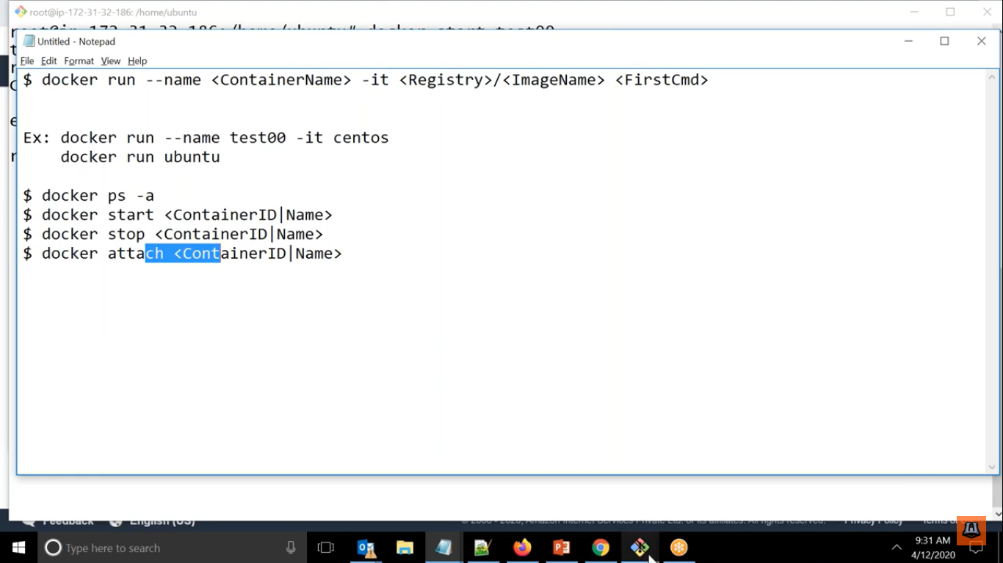

See below examples

root@ip-172-31-45-217:/home/ubuntu# docker ps

CONTAINER ID IMAGE COMMAND CREATED STATUS PORTS NAMES

1f8023be166b centos "/bin/bash" 16 minutes ago Up 14 seconds test001

root@ip-172-31-45-217:/home/ubuntu# docker attach test001

[root@1f8023be166b /]# hostname

1f8023be166b

[root@1f8023be166b /]#

Similarly before delete the container we have to stop it.

See below examples

ONTAINER ID IMAGE COMMAND CREATED STATUS PORTS NAMES

root@ip-172-31-45-217:/home/ubuntu# docker ps -a

CONTAINER ID IMAGE COMMAND CREATED STATUS PORTS NAMES

**1f8023be166b centos "/bin/bash" 25 minutes ago Exited (0) 9 seconds ago test001**

ebb13dc43414 centos "echo hi pankaj" 43 minutes ago Exited (0) 43 minutes ago condescending_engelbart

dcc4cedac011 centos "/bin/sh" 58 minutes ago Exited (0) 30 minutes ago cool_darwin

dcb96984c09f centos "/bin/bash" 58 minutes ago Exited (0) 58 minutes ago stupefied_goldstine

8c797ef8452f centos "/bin/bash" About an hour ago Exited (0) About an hour ago intelligent_hypatia

b1582664944c centos "/bin/bash" About an hour ago Exited (0) 29 minutes ago sad_stonebraker

**root@ip-172-31-45-217:/home/ubuntu# docker rm test001**

test001

root@ip-172-31-45-217:/home/ubuntu# docker ps -a

CONTAINER ID IMAGE COMMAND CREATED STATUS PORTS NAMES

ebb13dc43414 centos "echo hi pankaj" 44 minutes ago Exited (0) 44 minutes ago condescending_engelbart

dcc4cedac011 centos "/bin/sh" 58 minutes ago Exited (0) 30 minutes ago cool_darwin

dcb96984c09f centos "/bin/bash" 59 minutes ago Exited (0) 58 minutes ago stupefied_goldstine

8c797ef8452f centos "/bin/bash" About an hour ago Exited (0) About an hour ago intelligent_hypatia

b1582664944c centos "/bin/bash" About an hour ago Exited (0) 30 minutes ago sad_stonebraker

root@ip-172-31-45-217:/home/ubuntu#

Here we can say that container is deleted

We can start the container in 2 ways

1. In attach way where it will start in interactive way.
2. In deattach way in this time it will start the container, run any application which will be available inside it and we will give it in first command to start it then without temering it it will come out of it

It will not attach to your screen instead it will be running some application inside it if we give it in first cmd

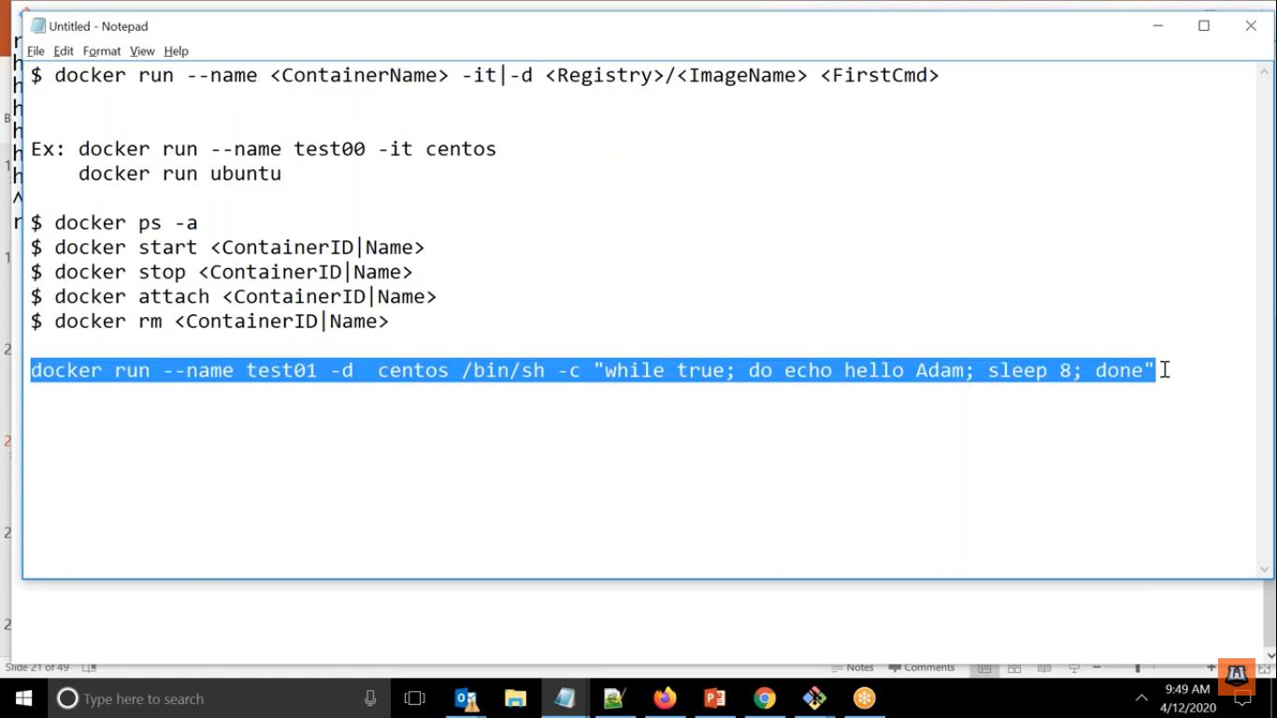

Here we can see we are starting in detach mode and giving first command

If you want your application to run you will use -d only not -it.

Docker run –name test1 -d centos /bin/bash -c “while true; do echo hello pankaj ; sleep 8; done “

If we want to see what is running inside container without going inside it.

You can see docker console logs

Using docker logs -f <ContainerID>

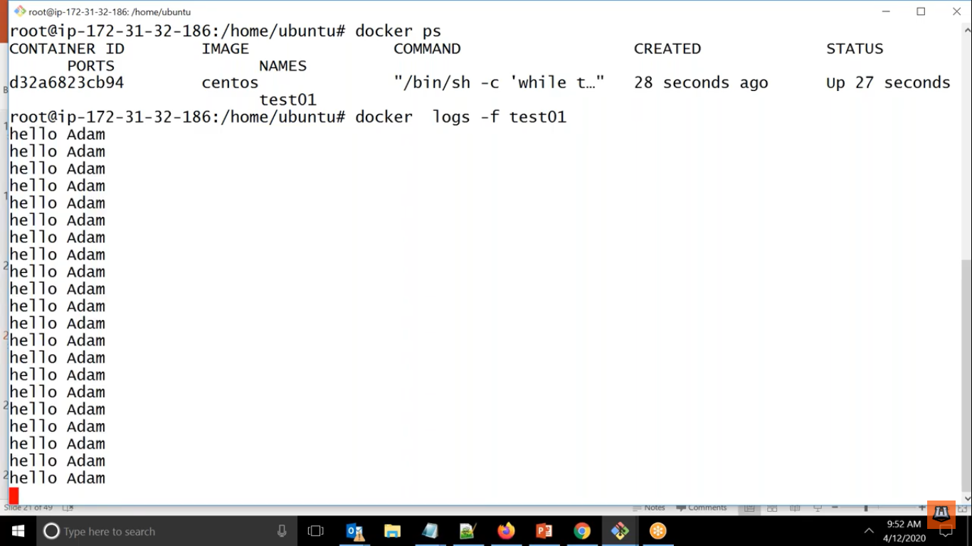

If Container is running in detach mode and want to see what is running inside and can run command also.

Docker **exec test01 hostname**

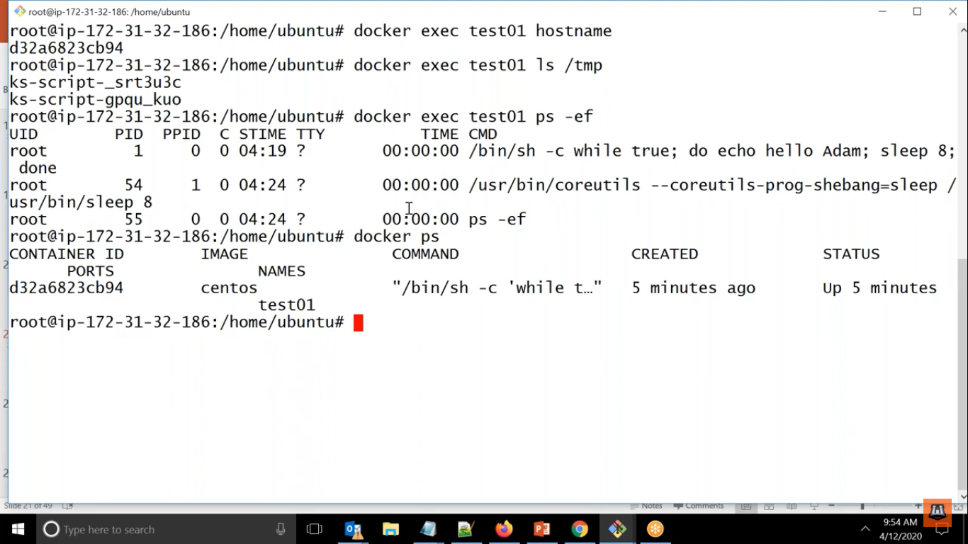

If you want to connect to any any container and go inside it interactively then we can use below command

Here docker exec -it test01 /bin/bash

In this way we are going inside in interactive mode and running the command in existing shell

If anytime we want to come out we can do exit it will kill the current pid only

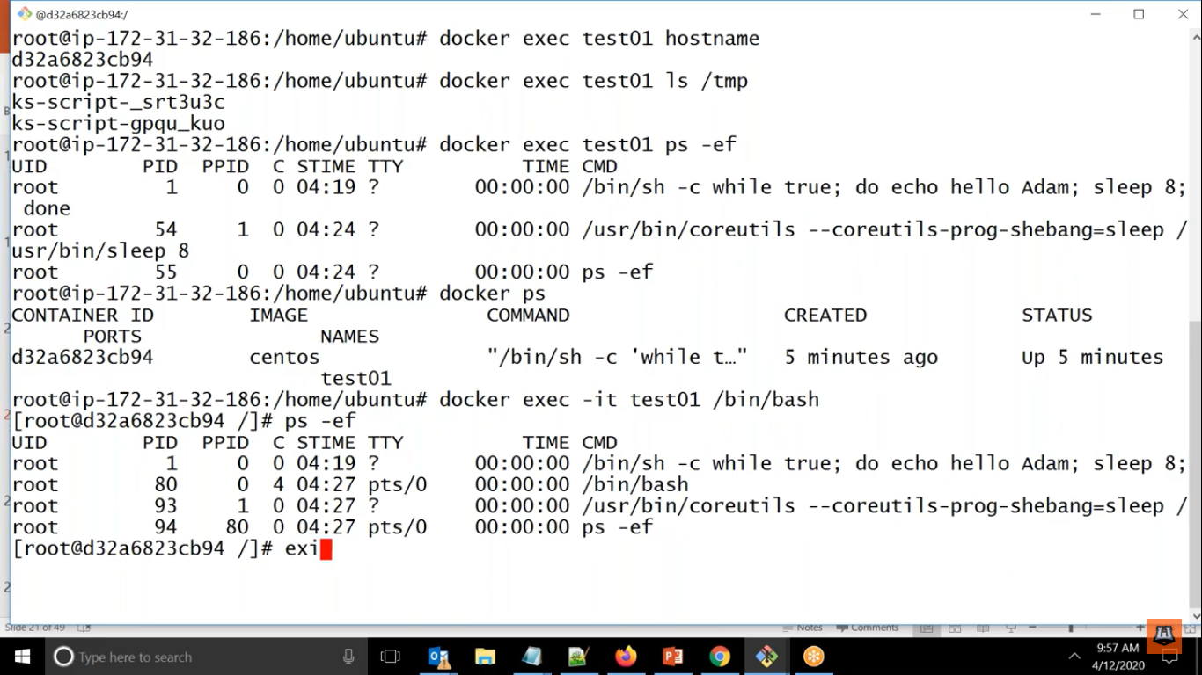

What all we have learn so far in container management.

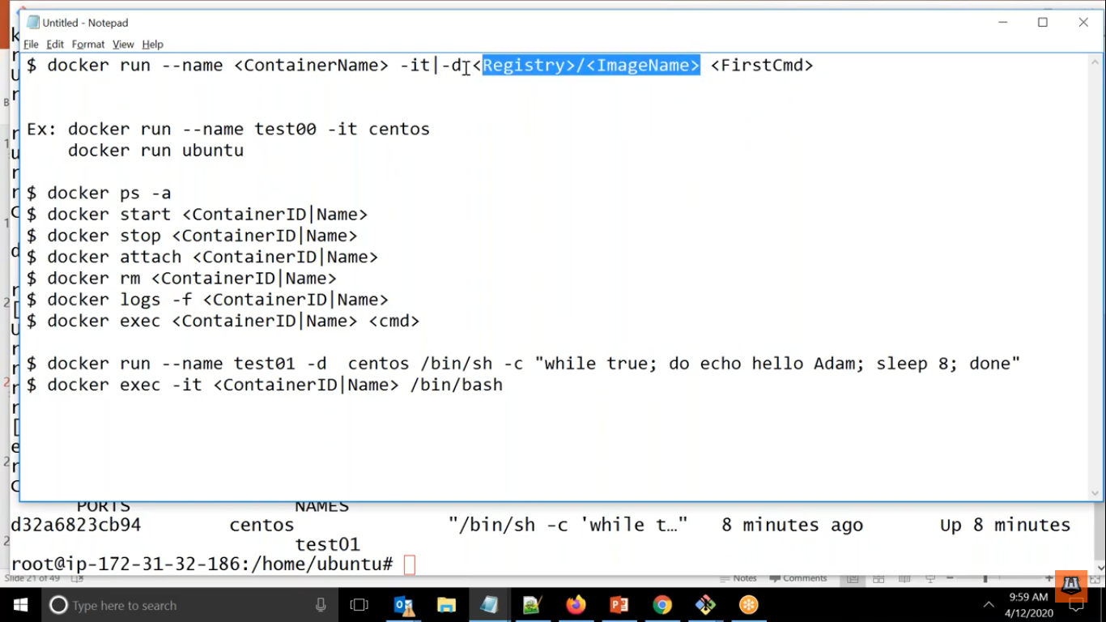

If we ant to pass any environment variable while creating it

We will use -e

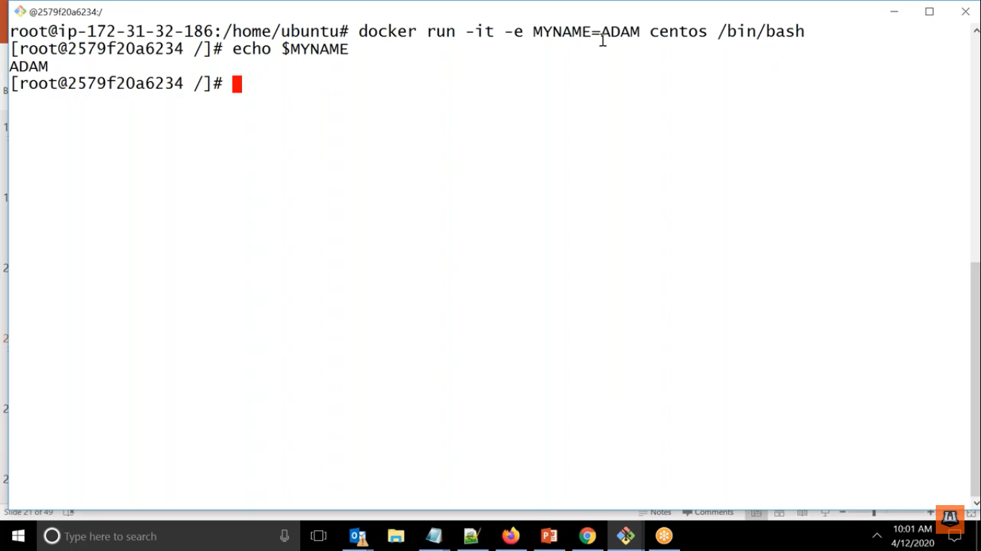

See examples

root@ip-172-31-45-217:/home/ubuntu# docker run --name test5 -e MYNAME=PANKAJ -it centos /bin/bash

[root@e91f5a01bfd1 /]# echo MYNAME

MYNAME

[root@e91f5a01bfd1 /]# echo $MYNAME

PANKAJ

[root@e91f5a01bfd1 /]#

If you want to create the container with some other path i.e. other than root directory.

You can use -w

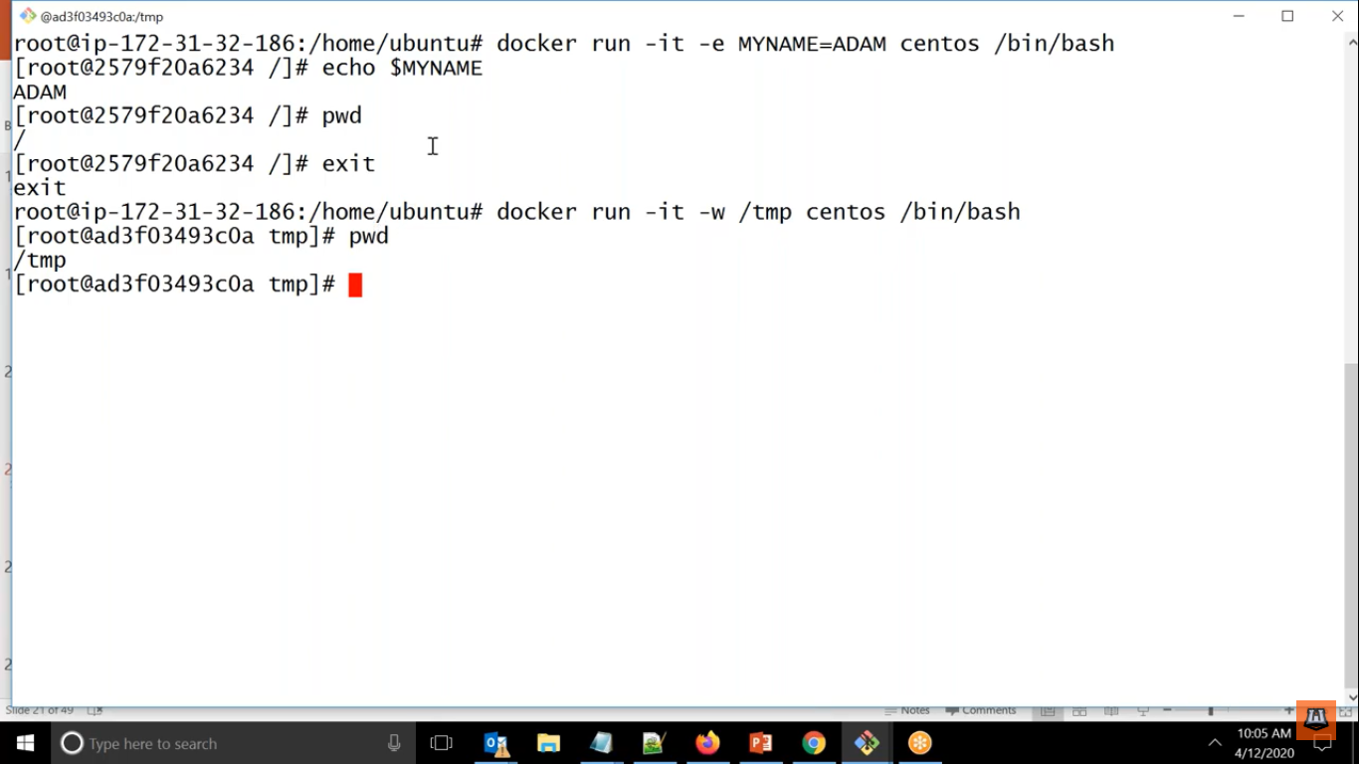

root@ip-172-31-45-217:/home/ubuntu# docker run --name test52 -e MYNAME=PANKAJJHA -it -w /tmp centos /bin/bash

[root@0fbdf9e55ac4 tmp]# pwd

/tmp

For copy a file from hostmachine to container or vice versa

Use cp command

Here docker cp <hostfile> <ContainerID> :<path>

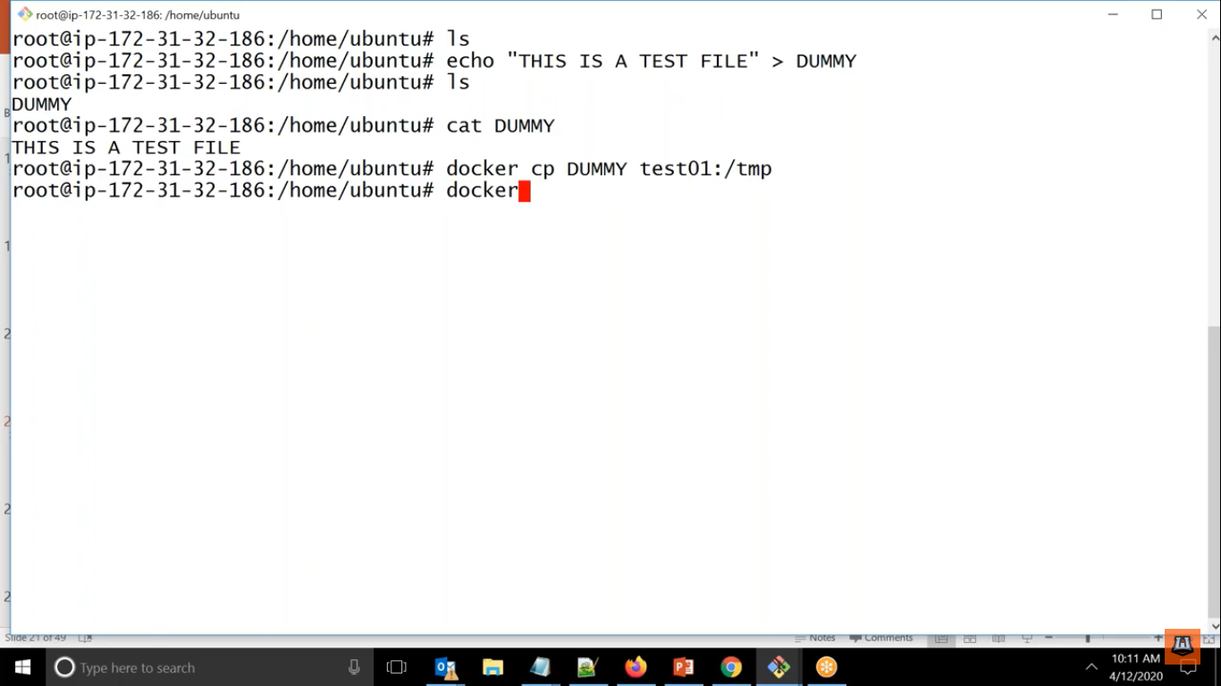

Here see below we are creating one file in host machine

And copying it to container

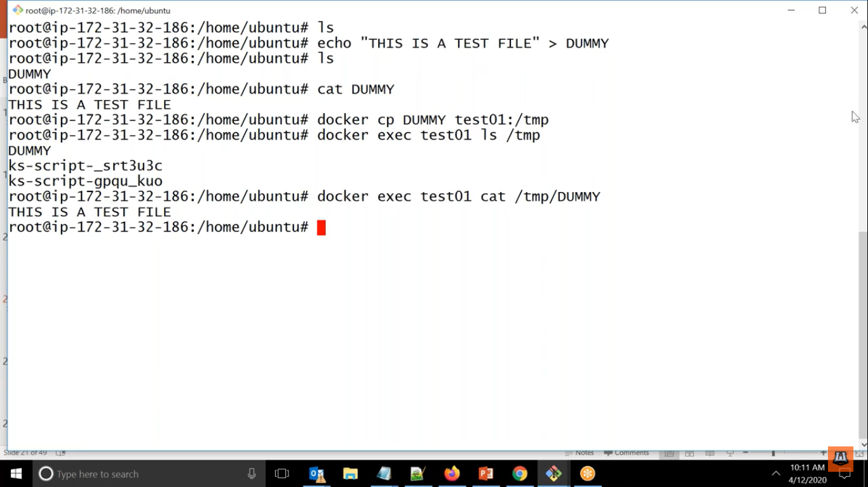

All learning till now in container management.

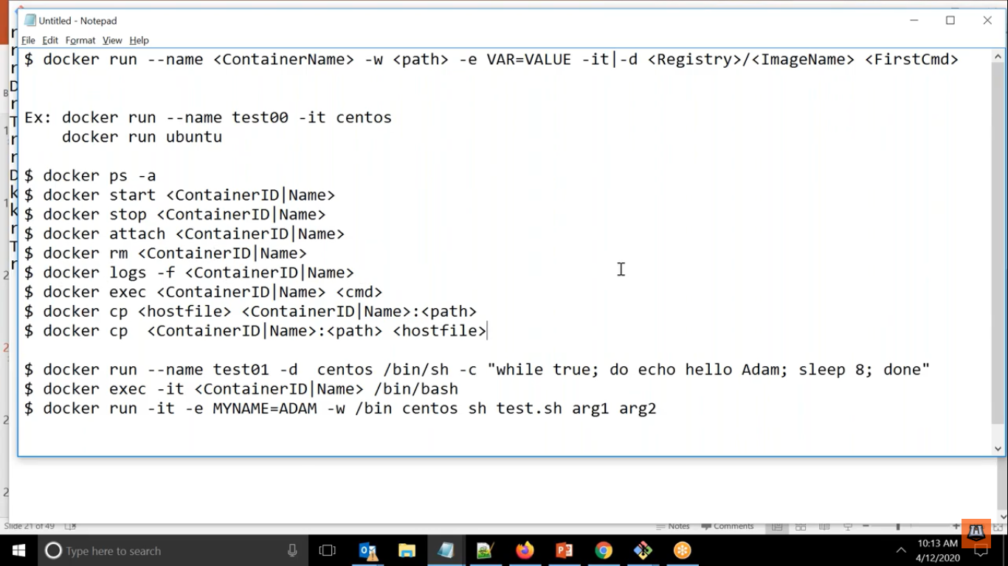

PORT MAPPING

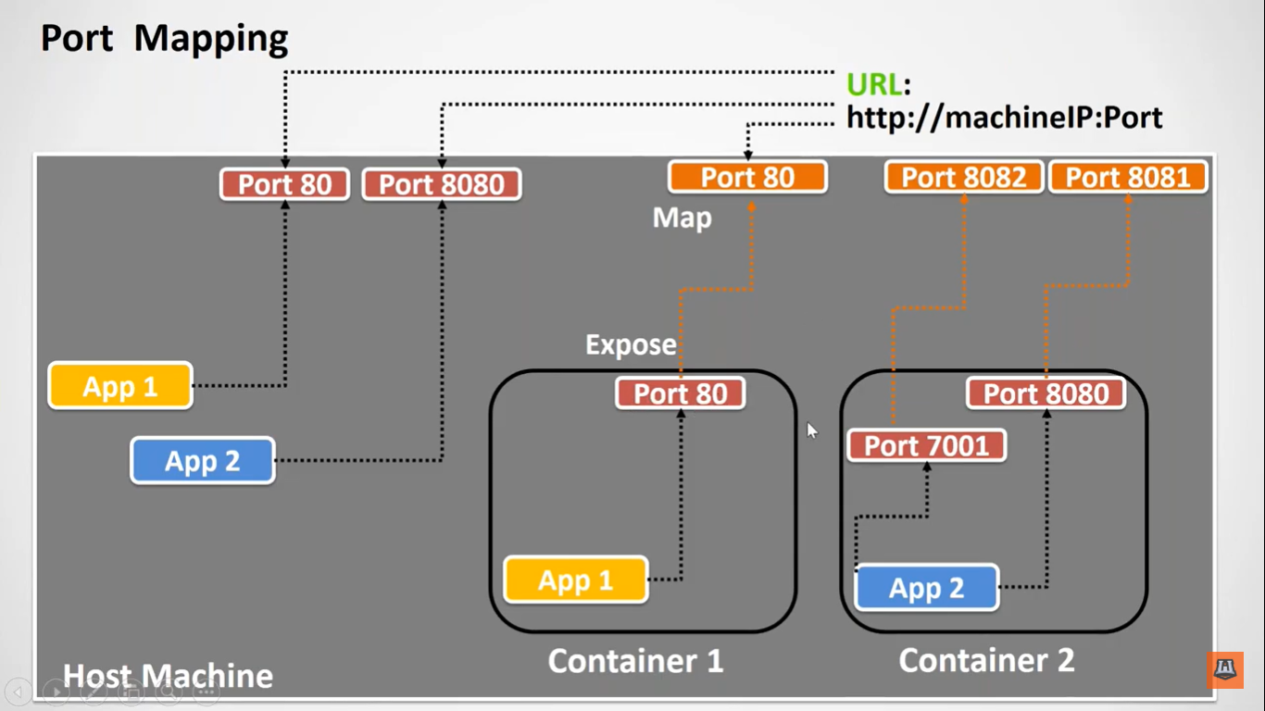

Here we can see that 2 application available in host machine and that are listening in 2 different ports so to access this application we have to access it via <http://machineIP:Port>

Same way inside container as well we have 2 applications are running in 2 different containers and as we know containers are isolated from each other and we cannot access the aaplication running inside the container externally.

To achieve it we will go through a concept called as port mapping

Here whatever applications are running on any port in that port we will expose it outside the container.

And same port we can map to available port in hostmachine.

Here docker run -it –name test001 -w /tmp <hostmachinePort><ContainerPort> centos /bin/bash

Examples:-

root@ip-172-31-45-217:/home/ubuntu# docker run -d --name apache -p 80:80 httpd

root@ip-172-31-45-217:/home/ubuntu# docker ps

CONTAINER ID IMAGE COMMAND CREATED STATUS PORTS NAMES

fc56d5ffe5ea httpd "httpd-foreground" 38 seconds ago Up 37 seconds 0.0.0.0:80->80/tcp apache

root@ip-172-31-45-217:/home/ubuntu# docker logs -f

"docker logs" requires exactly 1 argument.

See 'docker logs --help'.

Usage: docker logs [OPTIONS] CONTAINER

Fetch the logs of a container

root@ip-172-31-45-217:/home/ubuntu# docker logs -f apache

Working Examples

root@ip-172-31-45-217:/home/ubuntu# curl localhost:80

<html><body><h1>It works!</h1></body></html>

root@ip-172-31-45-217:/home/ubuntu#

Outside as well

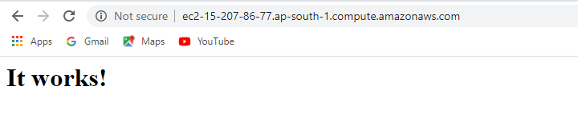

One more Examples:-

root@ip-172-31-45-217:/home/ubuntu# docker run -d --name nginx -p 8081:80 nginx

Unable to find image 'nginx:latest' locally

latest: Pulling from library/nginx

bf5952930446: Already exists

ba755a256dfe: Pull complete

c57dd87d0b93: Pull complete

d7fbf29df889: Pull complete

1f1070938ccd: Pull complete

Digest: sha256:36b74457bccb56fbf8b05f79c85569501b721d4db813b684391d63e02287c0b2

Status: Downloaded newer image for nginx:latest

f126d9cf136a0fd1b00a06411e8e3fd8a13480344373a07d7ea1b3703e219ae8

root@ip-172-31-45-217:/home/ubuntu#

Working:-

root@ip-172-31-45-217:/home/ubuntu# curl localhost:8081

<!DOCTYPE html>

<html>

<head>

<title>Welcome to nginx!</title>

<style>

body {

width: 35em;

margin: 0 auto;

font-family: Tahoma, Verdana, Arial, sans-serif;

}

</style>

</head>

<body>

<h1>Welcome to nginx!</h1>

<p>If you see this page, the nginx web server is successfully installed and

working. Further configuration is required.</p>

<p>For online documentation and support please refer to

<a href="http://nginx.org/">nginx.org</a>.<br/>

Commercial support is available at

<a href="http://nginx.com/">nginx.com</a>.</p>

<p><em>Thank you for using nginx.</em></p>

</body>

</html>

root@ip-172-31-45-217:/home/ubuntu#

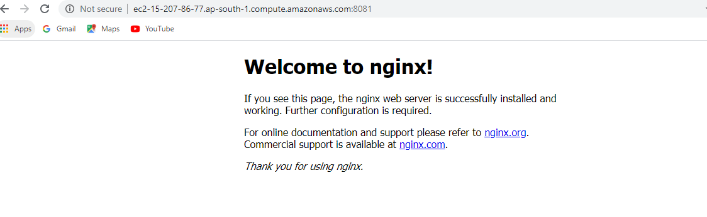

DOCKER VOLUMES:-

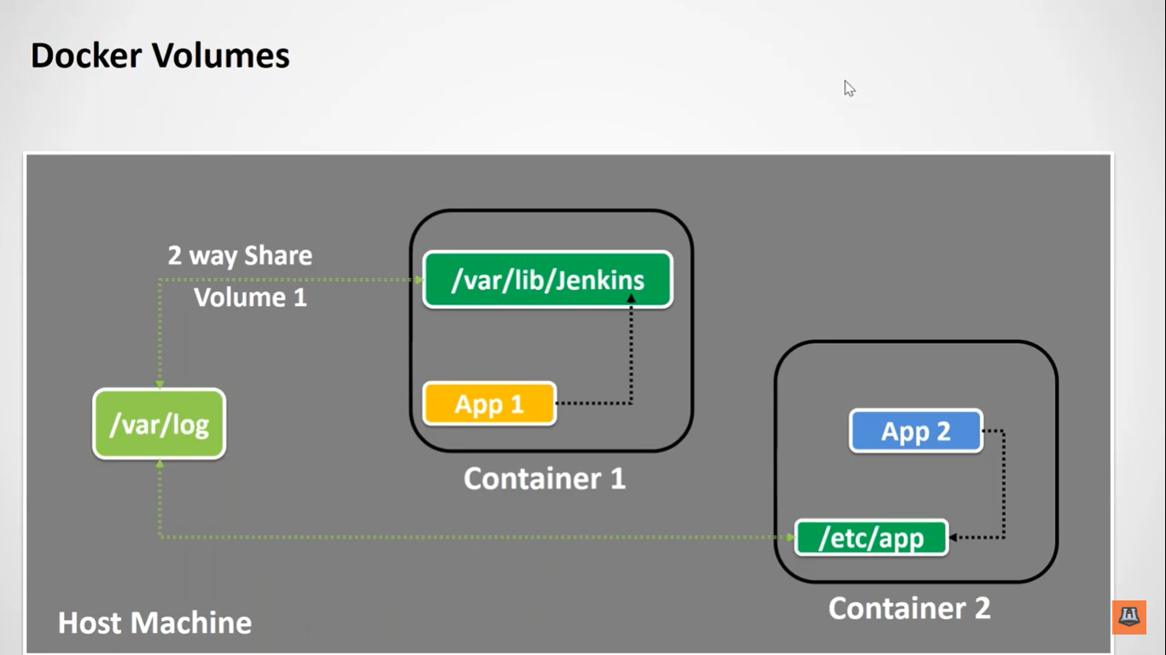

Here we are seeing if we want to share any data from container to host machines we can do it via Docker volumes

Here we will expose the data to the hostmachine in any specific external folder.

This is 2 way sharing i.e. whatever changes we will do in external folder i.e. host machines that will be reflected in container as well.

And same way we can share the data between two container as well

So we can say that Docker Volumes are nothing but sharing the data between container and hostmachine.

Here docker run -it –name c1 -v /tmp/host:/tmp/cont centos /bin/bash

Examples:-

Container:-

root@ip-172-31-45-217:/home/ubuntu# docker run -it --name con1 -v /tmp/host:/tmp/cont centos

[root@cf221dbc2024 /]# hostname

cf221dbc2024

[root@cf221dbc2024 /]# cd /tmp/cont

[root@cf221dbc2024 cont]# touch dummy

[root@cf221dbc2024 cont]# ls

dummy test

[root@cf221dbc2024 cont]#

Host Machine:-

root@ip-172-31-45-217:/home/ubuntu# cd /tmp/host

root@ip-172-31-45-217:/tmp/host# ls

dummy

root@ip-172-31-45-217:/tmp/host# touch test

root@ip-172-31-45-217:/tmp/host# ls

dummy test

root@ip-172-31-45-217:/tmp/host#

Here we can say that whatever changes we are doing in one place it is reflected in another place.

This will work even container is stopped we can access it.

Even container is crashed then copy of file will be available in host machine

Benefits of volume is 2 way sharing even we change in one place other place as well.

Note:- Whatever we are sharing it is being stored in

/var/lib/docker

So it should have enough space

We can see that it contains all the containers unique id.

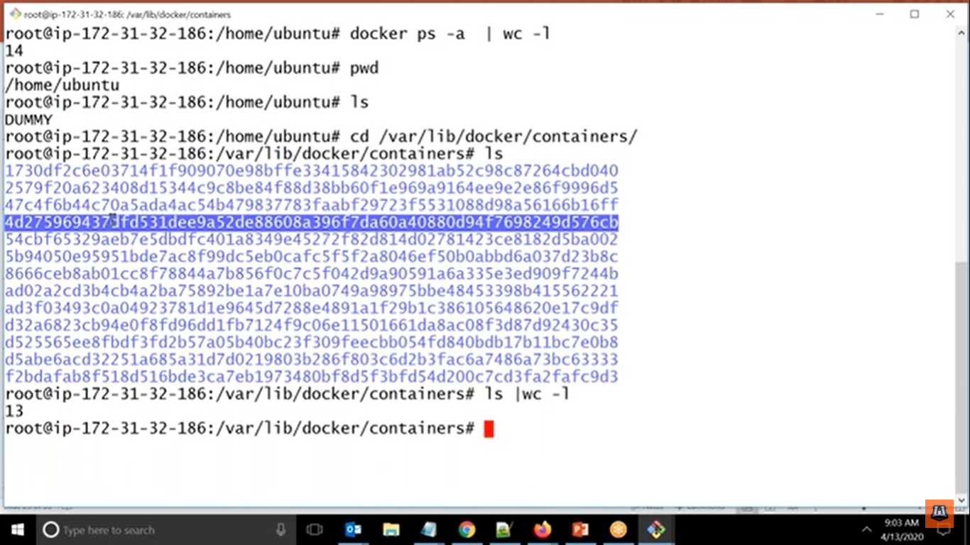



How to create image?

1. First we will take base image
2. We will add all the layers in it in container
3. Then we will create final image and checkin in registry

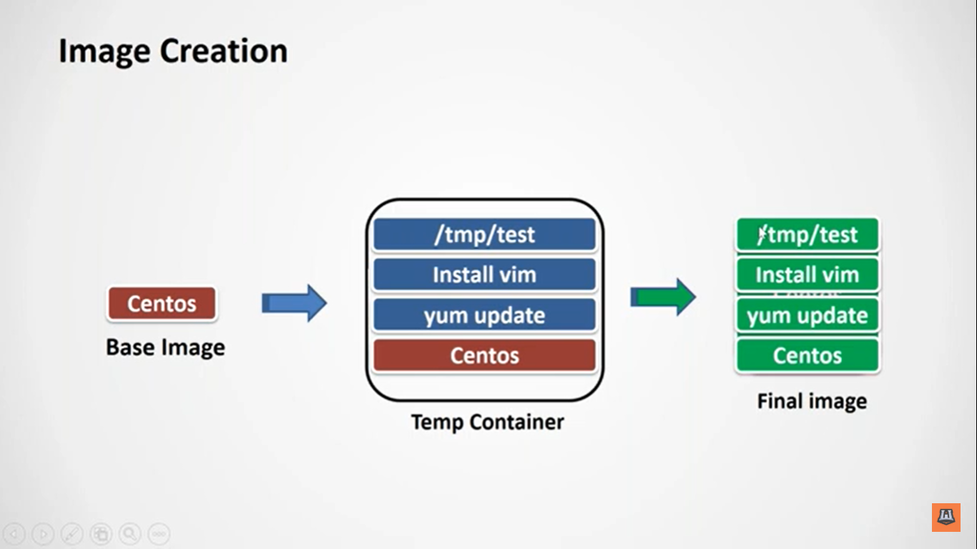

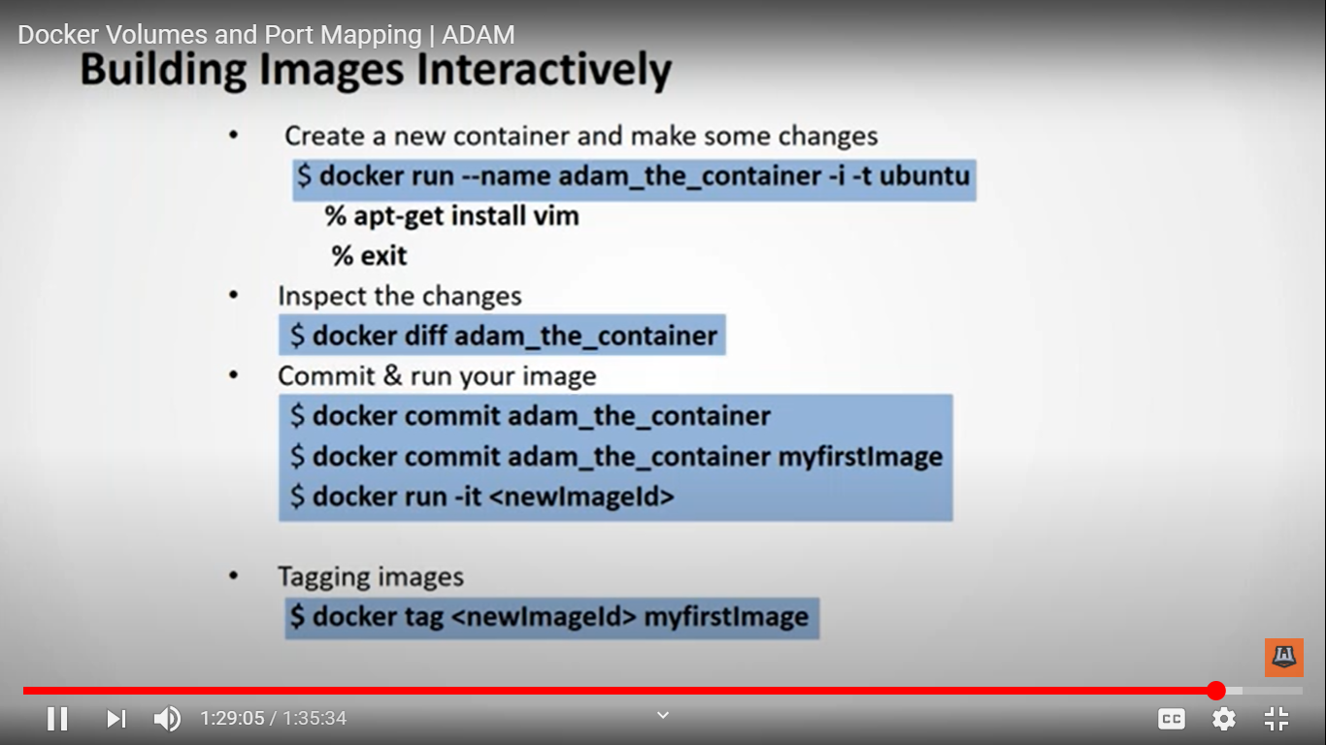

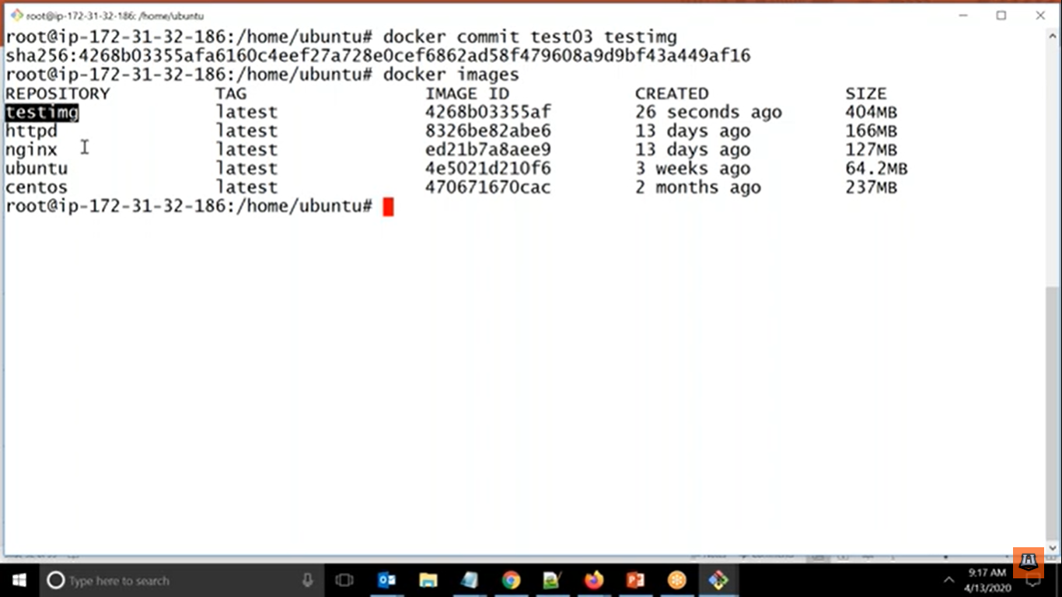

root@ip-172-31-45-217:/home/ubuntu# docker run -it --name img1 centos /bin/bash

[root@45c38a084305 /]# yum update

Failed to set locale, defaulting to C.UTF-8

CentOS-8 - AppStream 8.8 MB/s | 5.8 MB 00:00

CentOS-8 - Base 6.5 MB/s | 2.2 MB 00:00

CentOS-8 - Extras 9.6 kB/s | 7.3 kB 00:00

Dependencies resolved.

Nothing to do.

Complete!

[root@45c38a084305 /]# exit

exit

root@ip-172-31-45-217:/home/ubuntu# docker commit img1 testimg1

sha256:3044b530b3aee60d1ca735672bcf79995c0bf7a7bc1adf3f64dbddfd33c5803d

root@ip-172-31-45-217:/home/ubuntu# docker images

REPOSITORY TAG IMAGE ID CREATED SIZE

testimg1 latest 3044b530b3ae 6 seconds ago 235MB

centos latest 0d120b6ccaa8 20 hours ago 215MB

httpd latest a6ea92c35c43 5 days ago 166MB

nginx latest 08393e824c32 6 days ago 132MB

root@ip-172-31-45-217:/home/ubuntu# docker run -it testimg1 /bin/bash

[root@cf12a3b1f2cf /]# yum update

Failed to set locale, defaulting to C.UTF-8

Last metadata expiration check: 0:04:36 ago on Tue Aug 11 13:47:21 2020.

Dependencies resolved.

Nothing to do.

Complete!

[root@cf12a3b1f2cf /]#

See the examples above

DOCKER IMAGE MANAGEMENt :-

Docker can replace traditional deployment as well.

Here instead of delivering war or jar we can create a image and share it to qa and same copy of image can be given to other team as well.

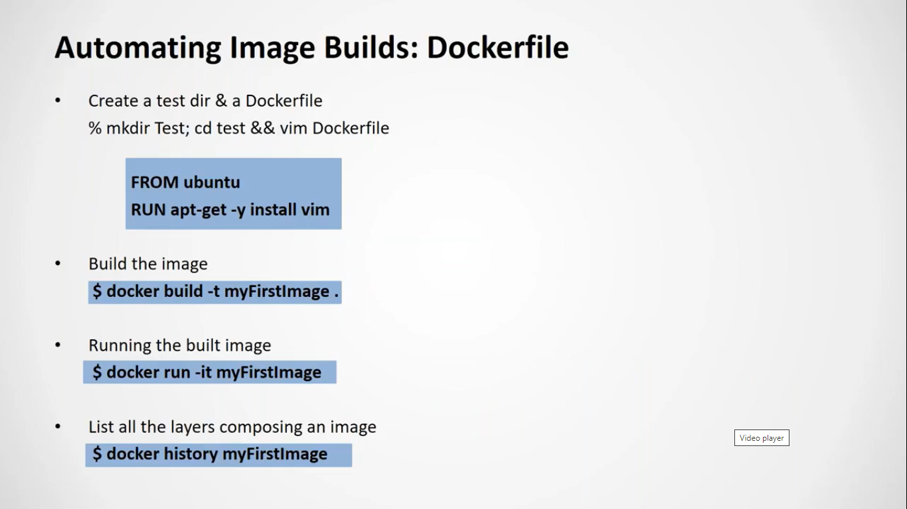

Steps to create image from Docker file

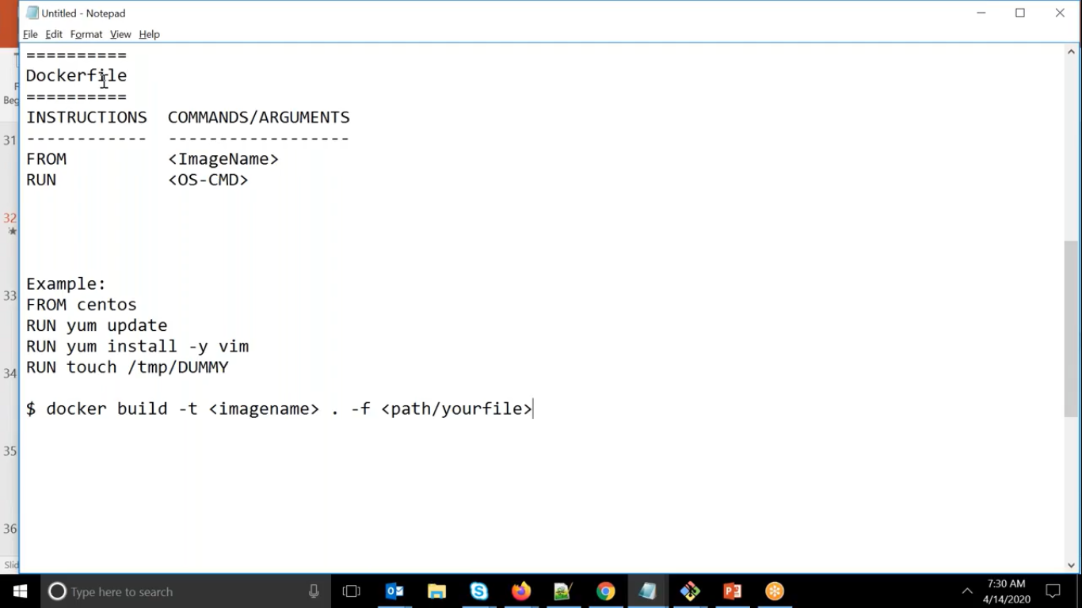

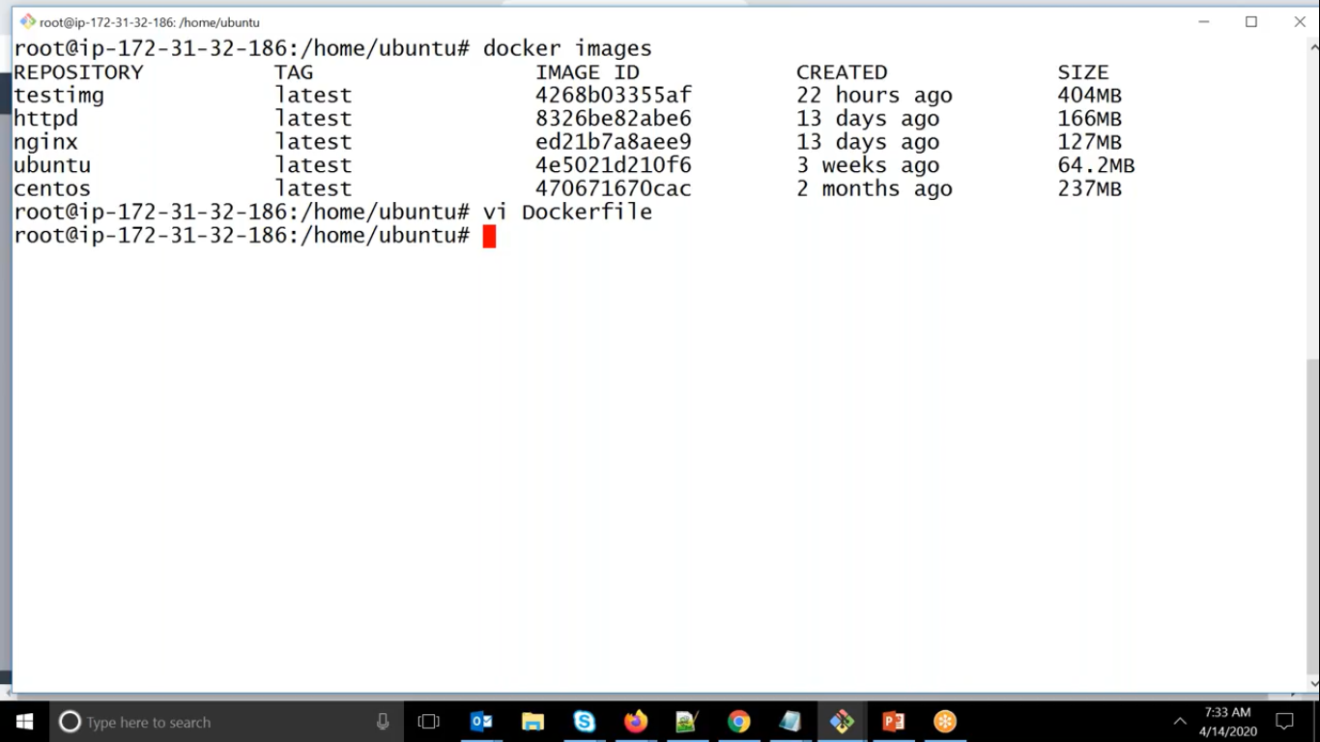

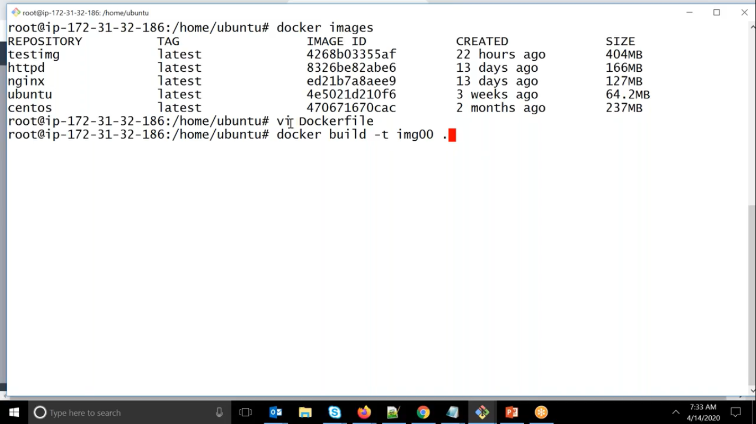

Here we were telling temporary container because once container is created it will remove

root@ip-172-31-45-217:/home/ubuntu# docker images

REPOSITORY TAG IMAGE ID CREATED SIZE

img001 latest dbaa0b31fbeb 38 seconds ago 283MB

testimg1 latest 3044b530b3ae 3 hours ago 235MB

centos latest 0d120b6ccaa8 22 hours ago 215MB

httpd latest a6ea92c35c43 5 days ago 166MB

nginx latest 08393e824c32 6 days ago 132MB

root@ip-172-31-45-217:/home/ubuntu#

Testing of Image Creation.

root@ip-172-31-45-217:/home/ubuntu# docker run -it img001 /bin/bash

[root@d2e9a56e1a09 /]# cd /tmp/

[root@d2e9a56e1a09 tmp]# ls

DUMMY ks-script-2n9owwnh ks-script-xm1o5azb

[root@d2e9a56e1a09 tmp]#

Through CMD we can give the first command, i.e. Default first command

In CMD if user does not pass any default command it will take it but if user give the first command that will be given as first priority

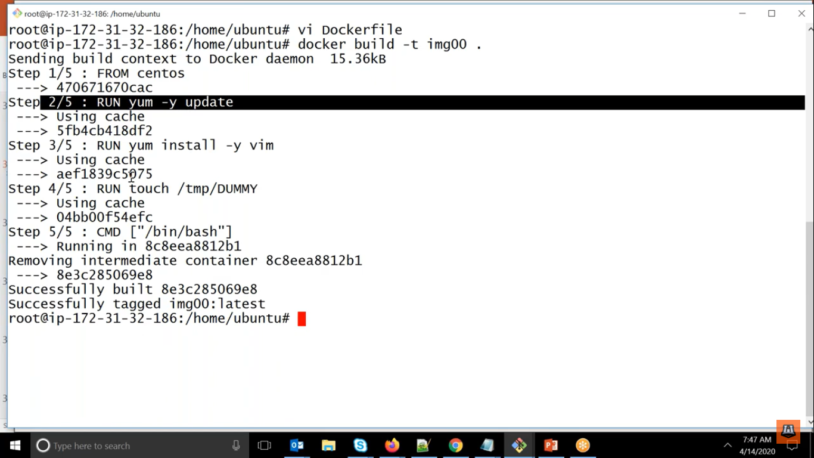

Through docker file from second time it will create the img very fastly because it is storing the step as layer so that the existing steps it will use from cache

Here we can see below it is overwrite by the command which user is passing.

root@ip-172-31-45-217:/home/ubuntu# docker run -it img001 /bin/sh

sh-4.4# ps -ef

UID PID PPID C STIME TTY TIME CMD

root 1 0 0 17:06 pts/0 00:00:00 /bin/sh

root 6 1 0 17:07 pts/0 00:00:00 ps -ef

Instead of /bin/bash it is taking /bin/sh

Here if you want to write the logs then there is no direct way of storing the logs so we will be redirect the logs to text file only.

ENTRYPOINT <Default-First-cmd>

Here in ENTRYPOINT if user is not passing any cmd then it will be considered as default first command

But if user pass any command then it will not be override instead it will be added as arguments

It will be appending to the existing one

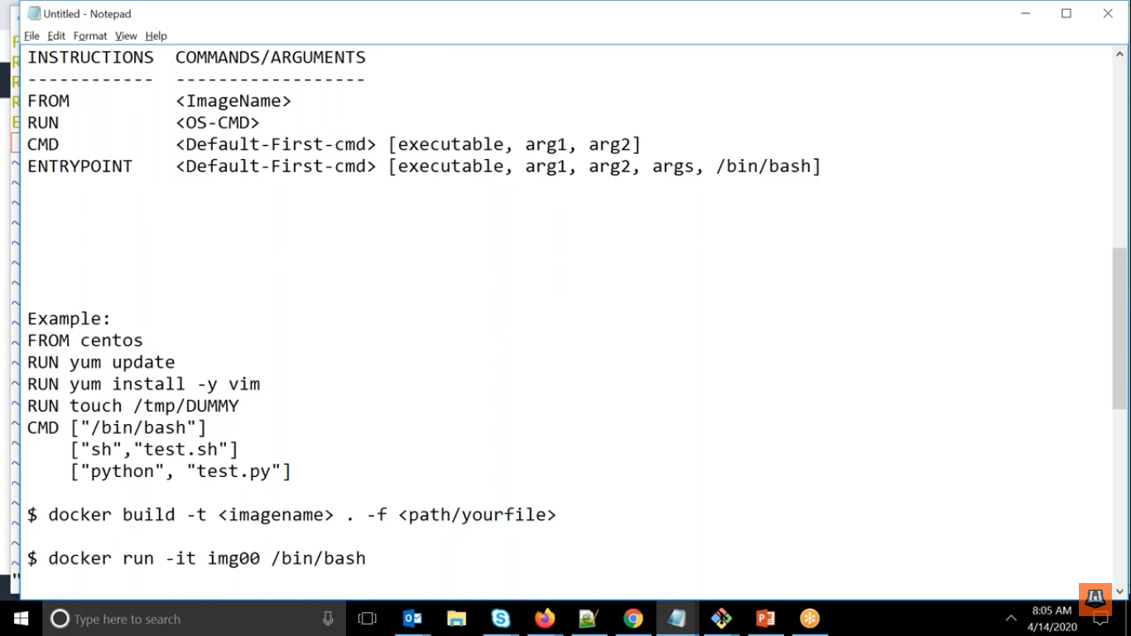

root@ip-172-31-45-217:/home/ubuntu# vi Dockerfile

root@ip-172-31-45-217:/home/ubuntu# docker build -t img001 .

Sending build context to Docker daemon 14.34kB

Step 1/5 : FROM centos

---> 0d120b6ccaa8

Step 2/5 : RUN yum update

---> Using cache

---> daddf93687ce

Step 3/5 : RUN yum install -y vim

---> Using cache

---> 8d544a5be986

Step 4/5 : RUN touch /tmp/DUMMY

---> Using cache

---> dbaa0b31fbeb

Step 5/5 : ENTRYPOINT ["echo", "hi pankaj"]

---> Running in 9e52c4535a6e

Removing intermediate container 9e52c4535a6e

---> 30ef9deaadd6

Successfully built 30ef9deaadd6

Successfully tagged img001:latest

root@ip-172-31-45-217:/home/ubuntu# docker run -it img001 /bin/sh

hi pankaj /bin/sh

Here we can see that the user command is taken as arguments along with default command.

UseCase:- If in your image if you want to pass some argument along with default command then we will be use ENTRYPOINT

It is better to use one ENTRYPOINT because it will take the last available.

By seeing image we cannot tell which command is used as first command in that case while running docker run command if it is allowing to overwrite then CMD otherwise ENTRYPOINT.

We can set Environment variable while creating image.

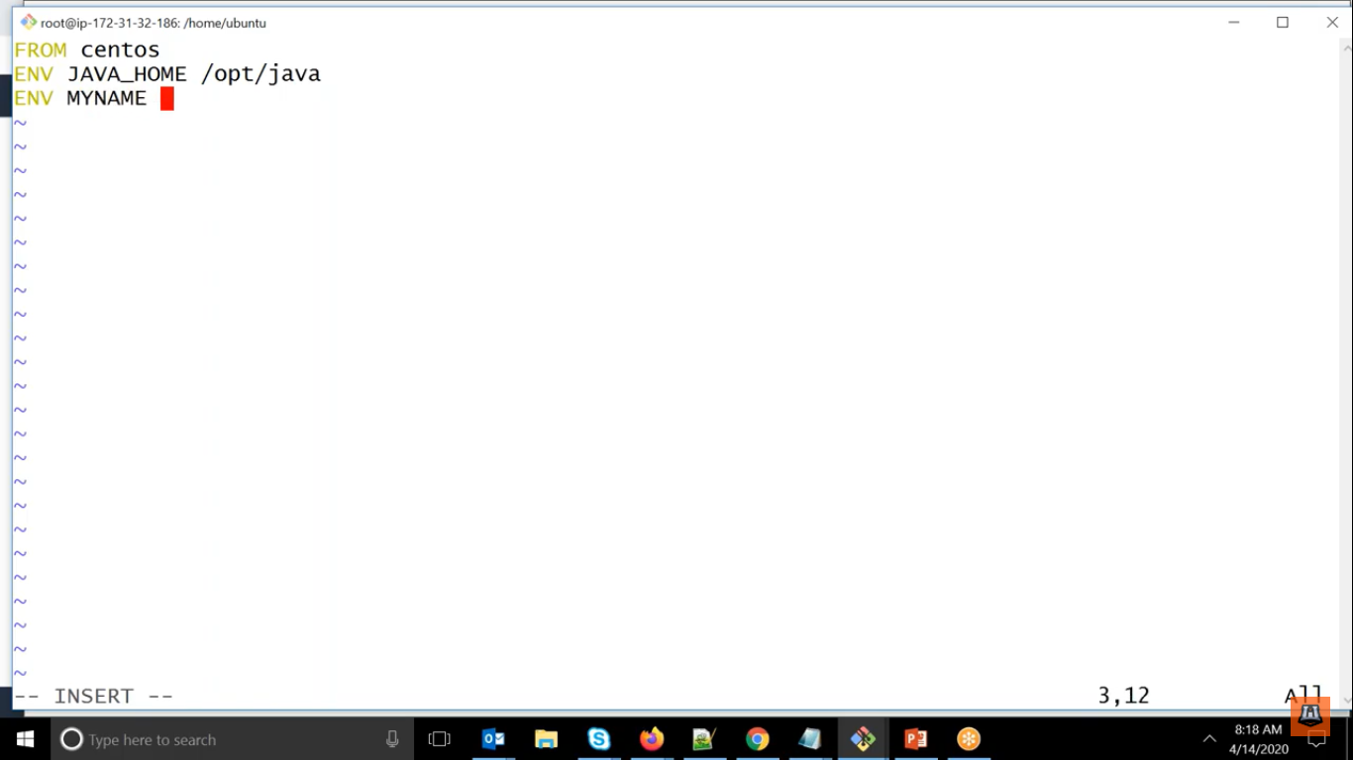

See the examples below

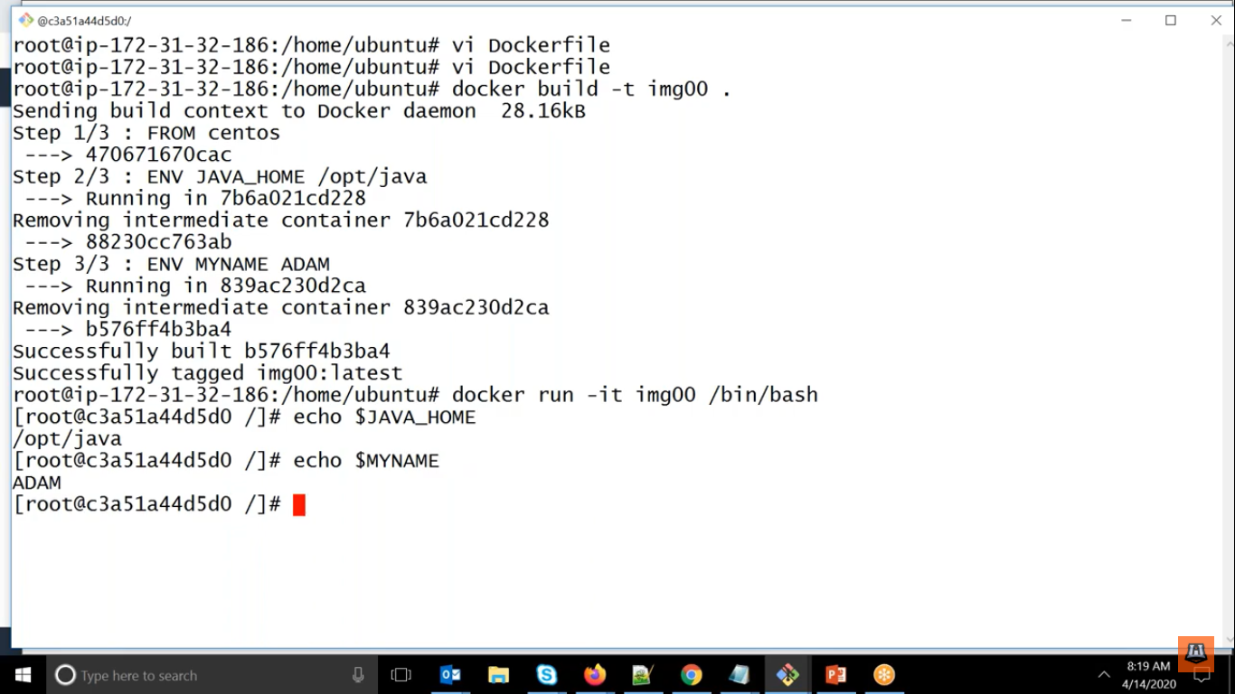

Examples Again

root@ip-172-31-45-217:/home/ubuntu# docker run -it img001

hi pankaj

root@ip-172-31-45-217:/home/ubuntu# vi Dockerfile

root@ip-172-31-45-217:/home/ubuntu# docker build -t img001 .

Sending build context to Docker daemon 14.34kB

Step 1/2 : FROM centos

---> 0d120b6ccaa8

Step 2/2 : ENV MYNAME PANKAJ

---> Running in de040a12ff97

Removing intermediate container de040a12ff97

---> 7e8290c80337

Successfully built 7e8290c80337

Successfully tagged img001:latest

root@ip-172-31-45-217:/home/ubuntu# docker run -it img001

[root@9c4aaeac3bc5 /]# echo $MYNAME

PANKAJ

Here if you note that with whatever user we were building the image with same user it was running also i.e. default user called as root.

But if we want it to run as different user we can user USER to do that.

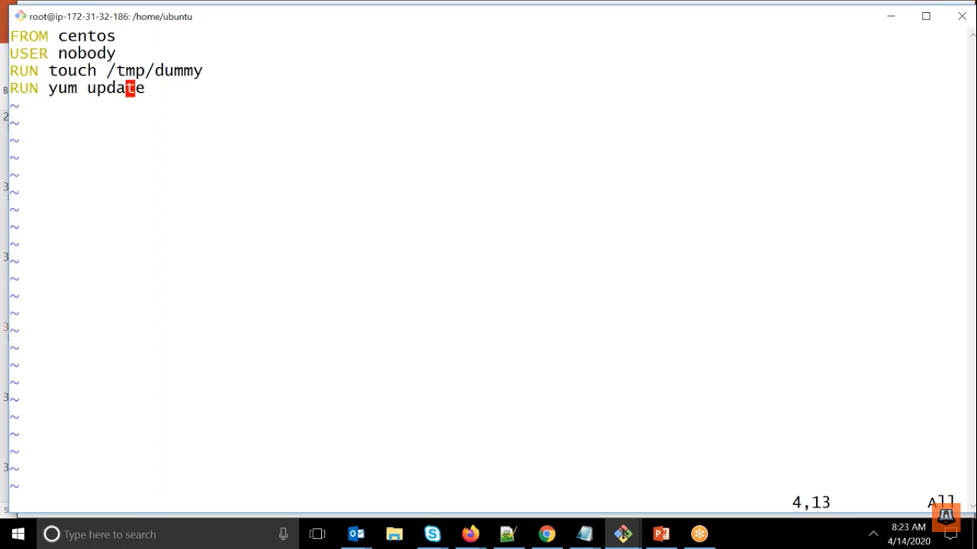

ubuntu@ip-172-31-45-217:~$ sudo su

root@ip-172-31-45-217:/home/ubuntu# vi Dockerfile

root@ip-172-31-45-217:/home/ubuntu# docker build -it img002 .

unknown shorthand flag: 'i' in -it

See 'docker build --help'.

root@ip-172-31-45-217:/home/ubuntu# docker build -t img002 .

Sending build context to Docker daemon 15.87kB

Step 1/5 : FROM centos

---> 0d120b6ccaa8

Step 2/5 : ENV MYNAME PANKAJ

---> Using cache

---> 7e8290c80337

Step 3/5 : USER nobody

---> Running in 3ba5d963a16b

Removing intermediate container 3ba5d963a16b

---> 3b1e9c7008ba

Step 4/5 : RUN touch /tmp/host

---> Running in 06bd666a4c03

Removing intermediate container 06bd666a4c03

---> 8d41751af045

Step 5/5 : RUN yum update

---> Running in 9455a66c8097

Error: This command has to be run under the root user.

The command '/bin/sh -c yum update' returned a non-zero code: 1

root@ip-172-31-45-217:/home/ubuntu#

Here we can see that we have giver yum update with nobody user which is not having access to do it

One thing to be noted that we can swith to different user also while creating the container

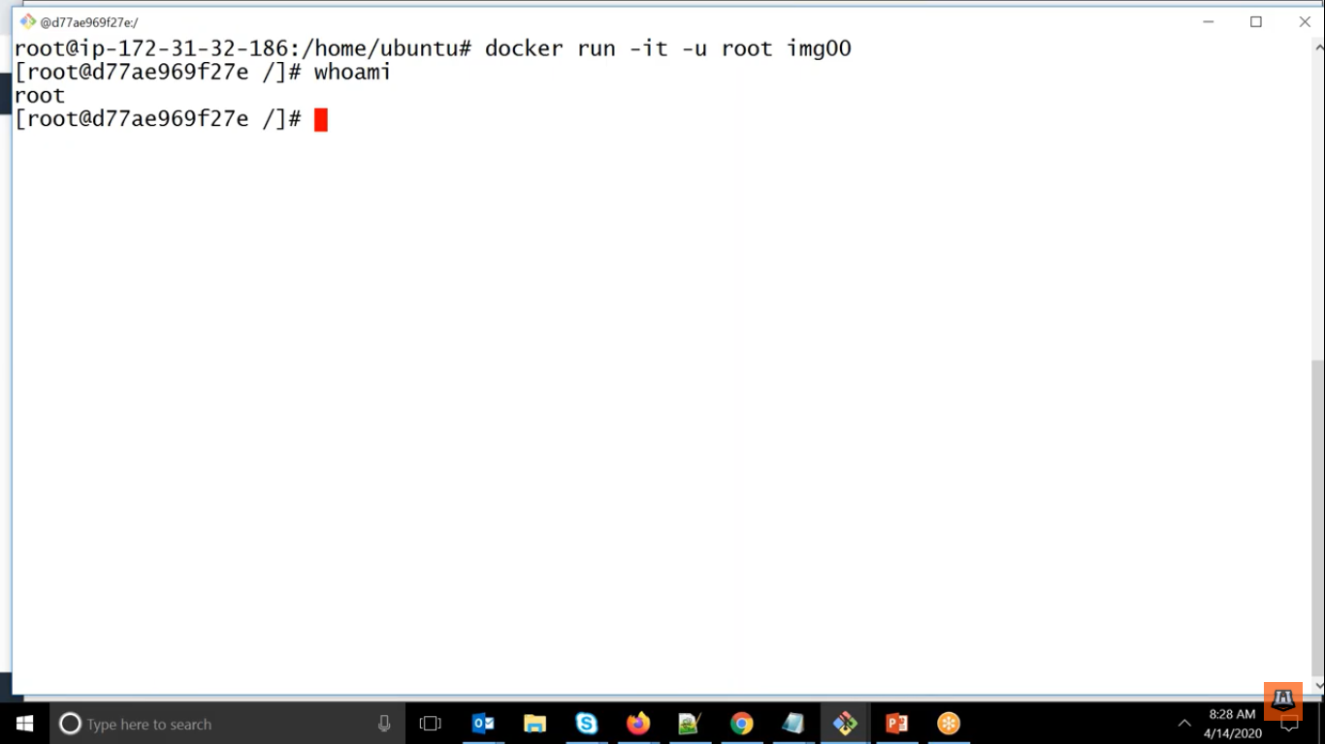

One morething we can give multiple users while creating image and last one will be the default user

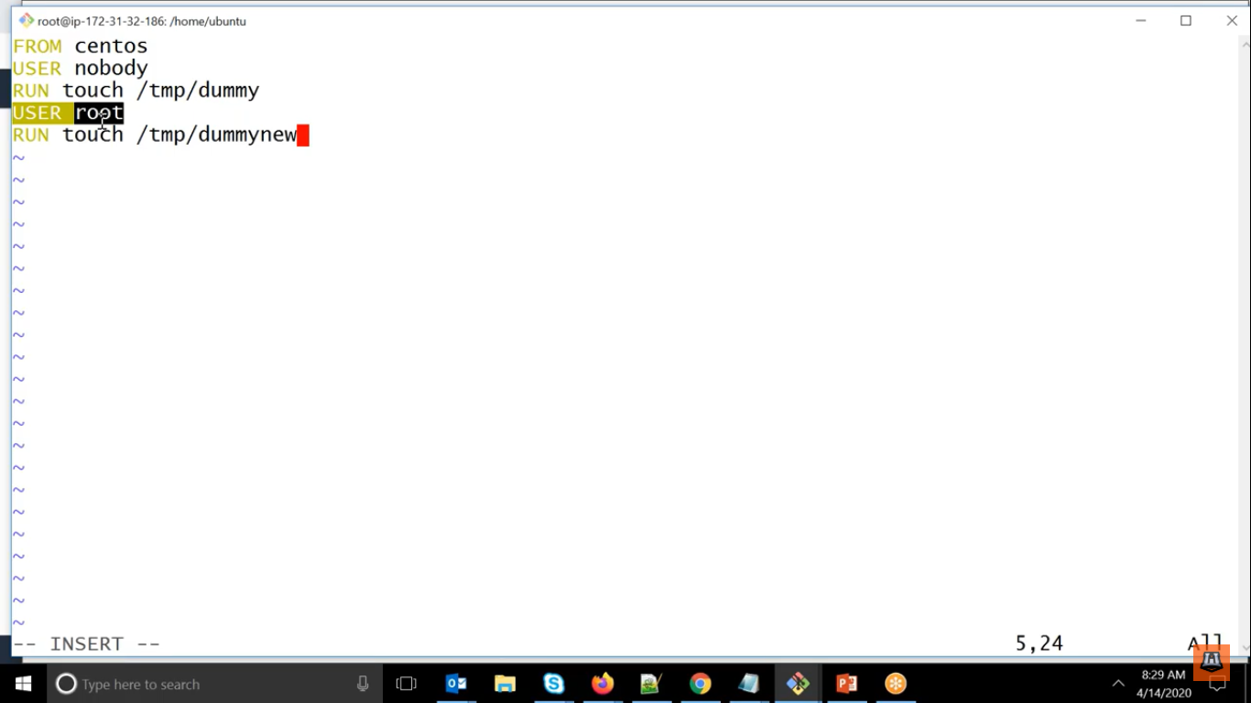

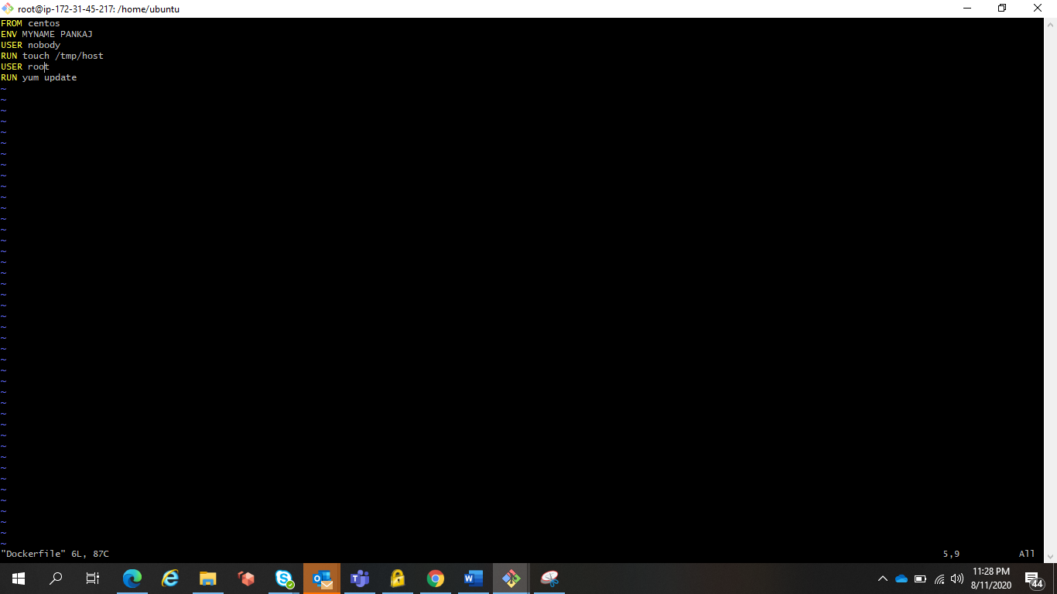

We can also change the workind directory also.

Using WORKDIR

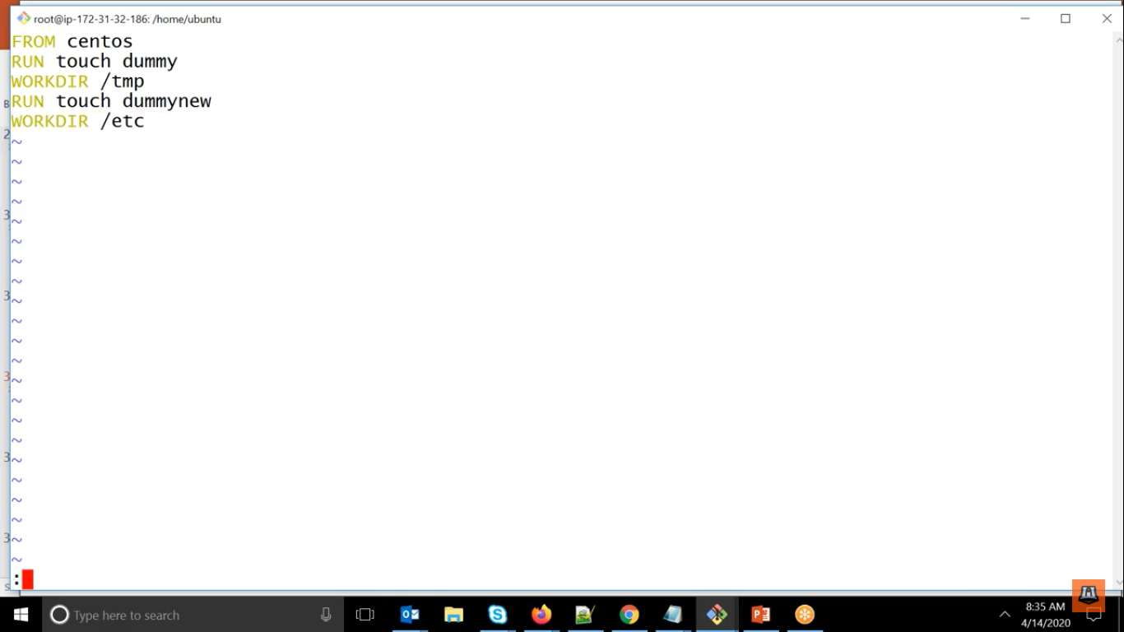

Successfully tagged img002:latest

root@ip-172-31-45-217:/home/ubuntu# docker run -it img002

[root@20e7621ab989 tmp]#

Here we can see that default folder is /tmp

Its meaning to specify from which path you will be executing all instruction

We can change it also while creating the container.

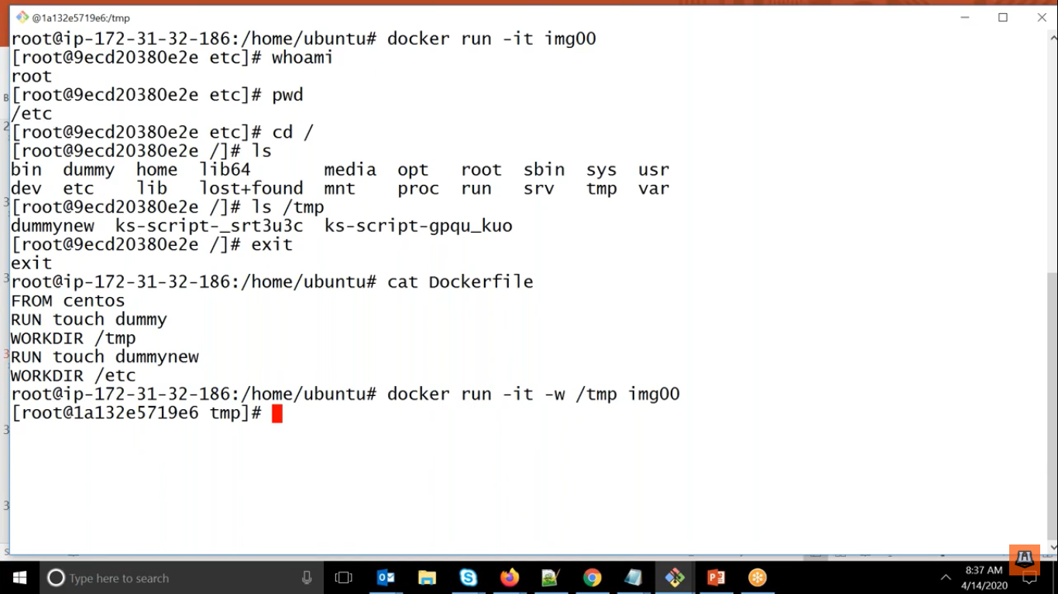

root@ip-172-31-45-217:/home/ubuntu# docker run -w /etc -it img002

[root@6ac92116bc13 etc]#

If you want file to be copied while creating the container that also we can do.

Using COPY command.

COPY <hostsrc> <destsrc>

It will copy the file by using relative path i.e. current directory

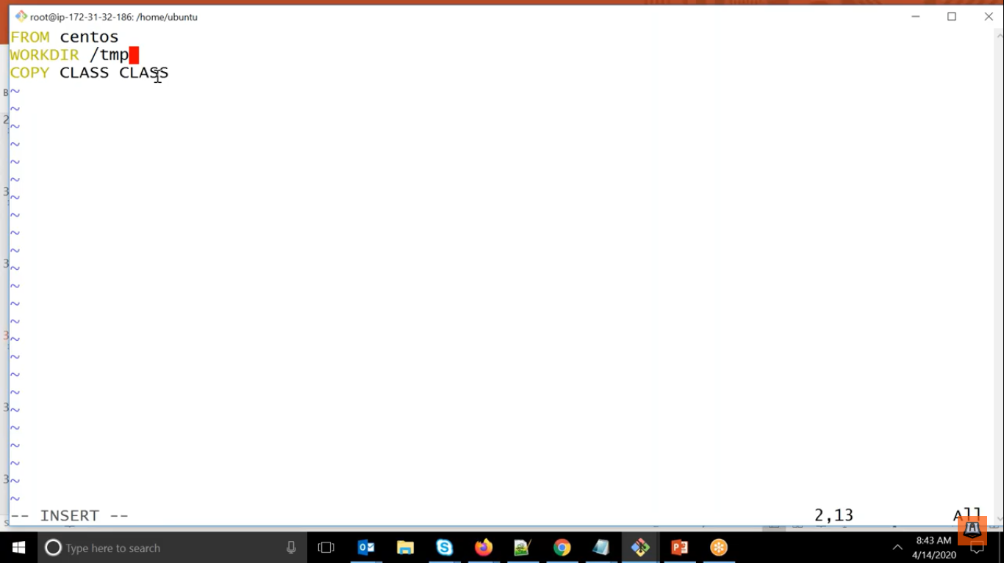

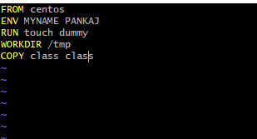

root@ip-172-31-45-217:/home/ubuntu# docker run -it img002

[root@8286ff260391 tmp]# ls

class ks-script-2n9owwnh ks-script-xm1o5azb

We can see that class file is available in tmp directory of container.

If you want to copy more than one file we can use ADD command

Here we can copy tar also

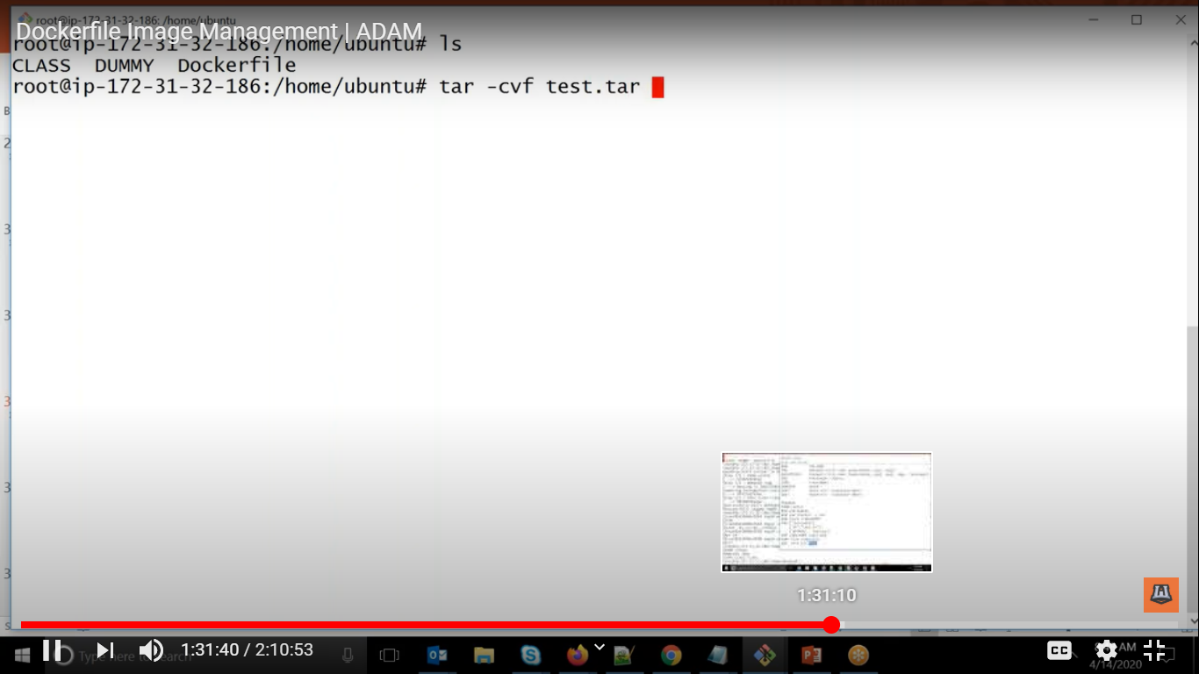

Created a tar with all the files

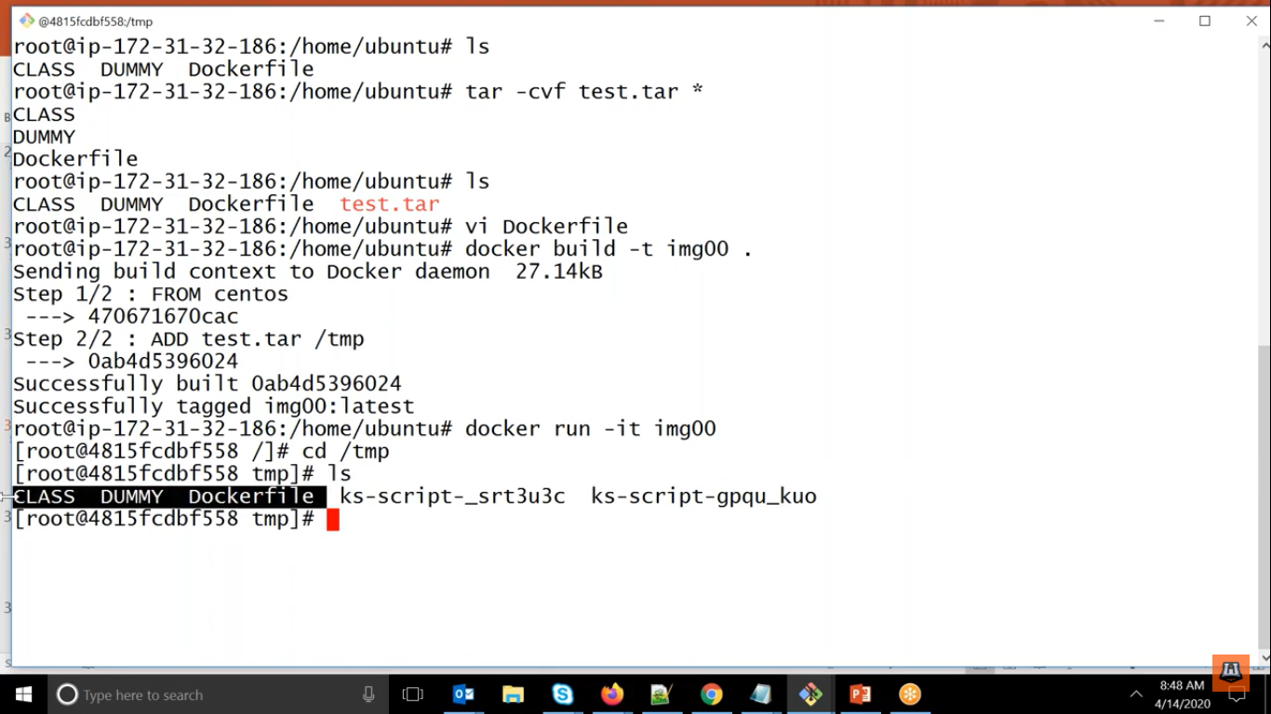

If we remember while port mapping that time we were using container port and to be use that port first we have to EXPOSE.

IF you want EN variable to be available in temporary container but not in the final image.

Then we will be using

ARG=VALUE

It is used only for executing the steps but if you want in your final img then go for ENV

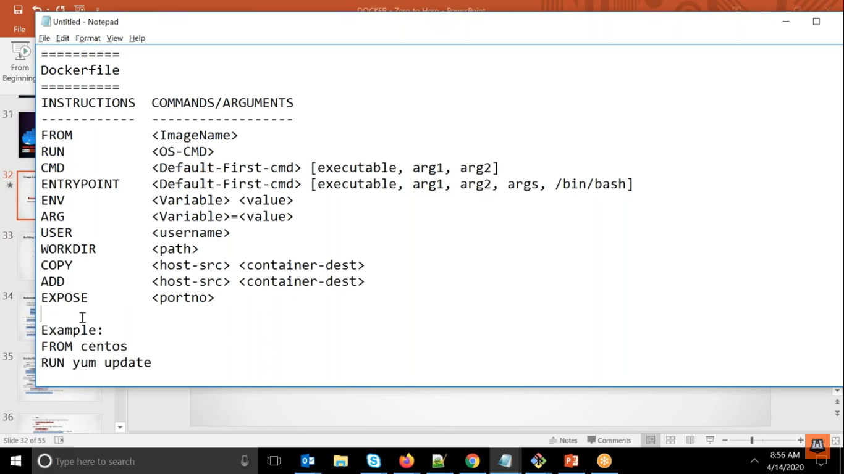

What we have learnt as far now in image management

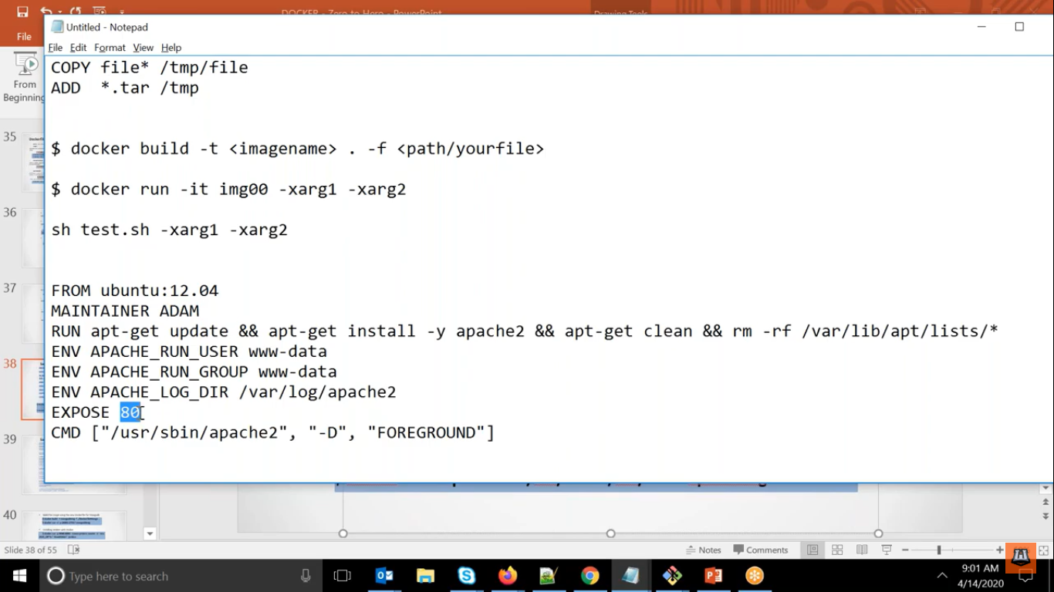

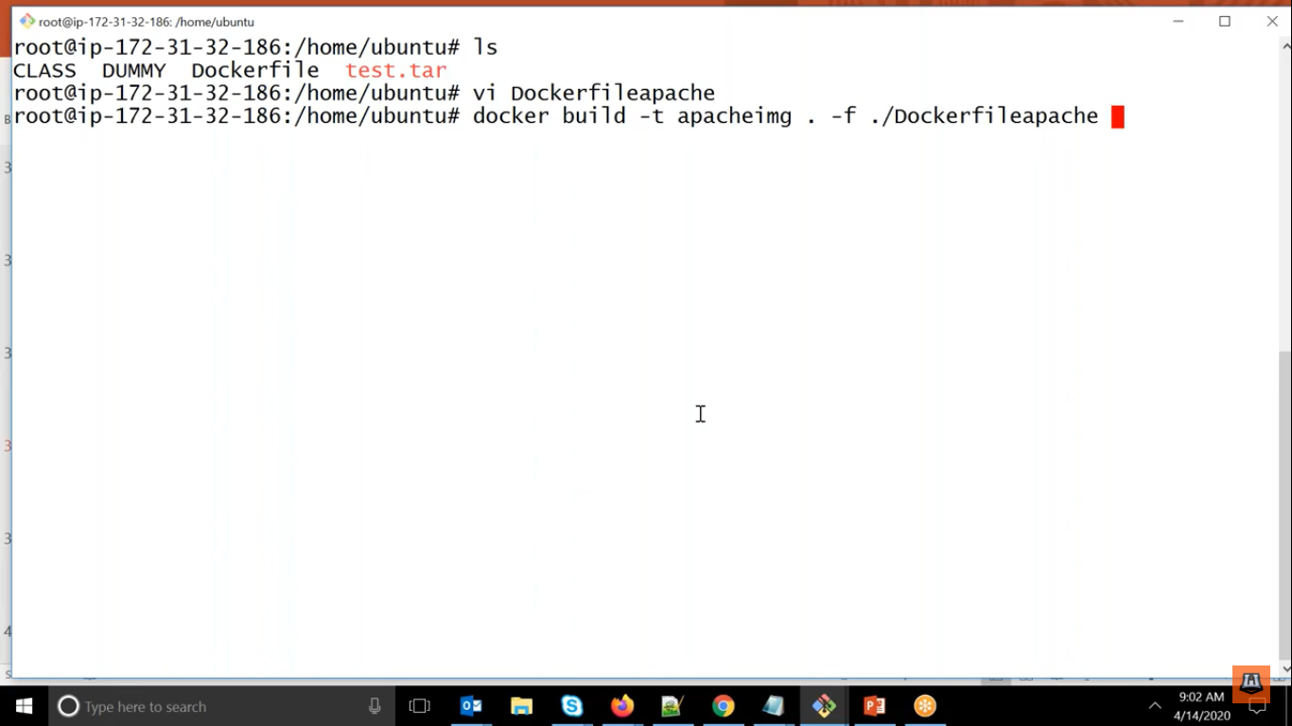

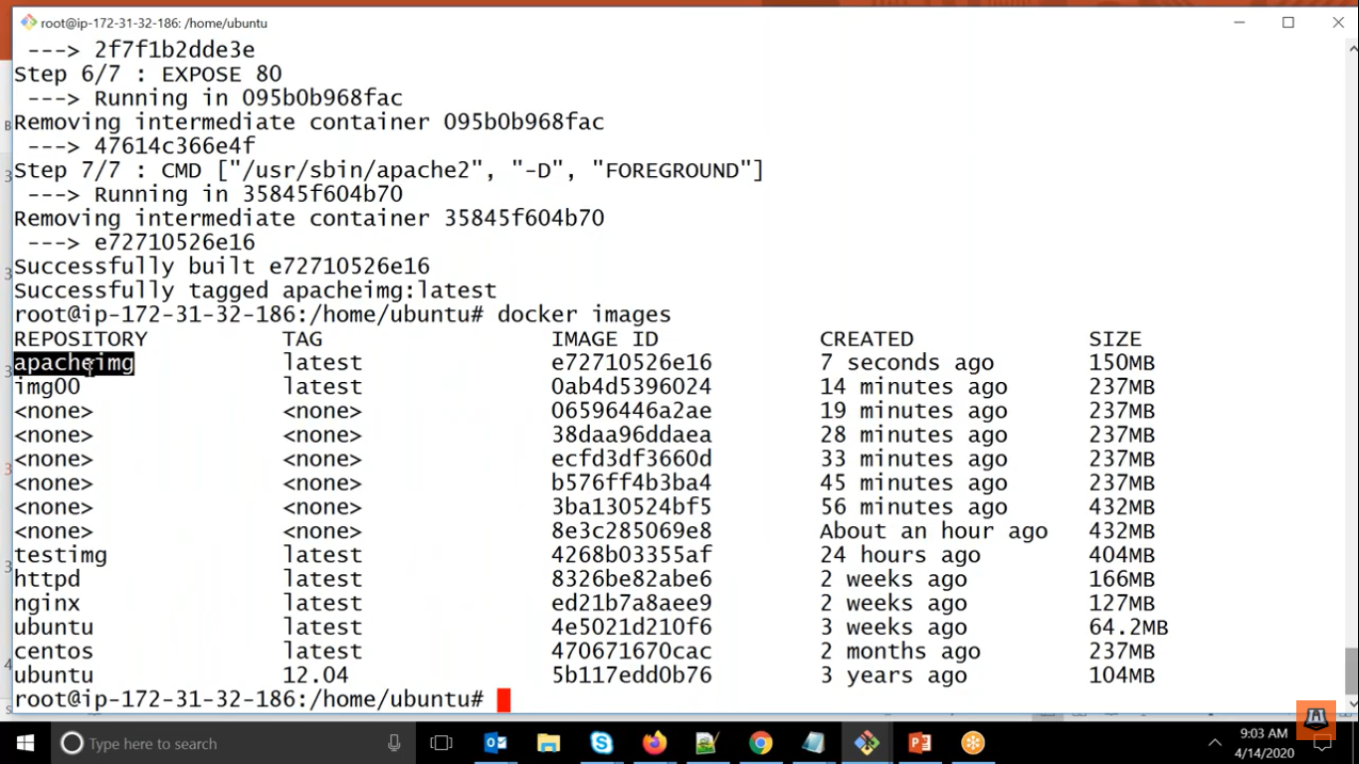

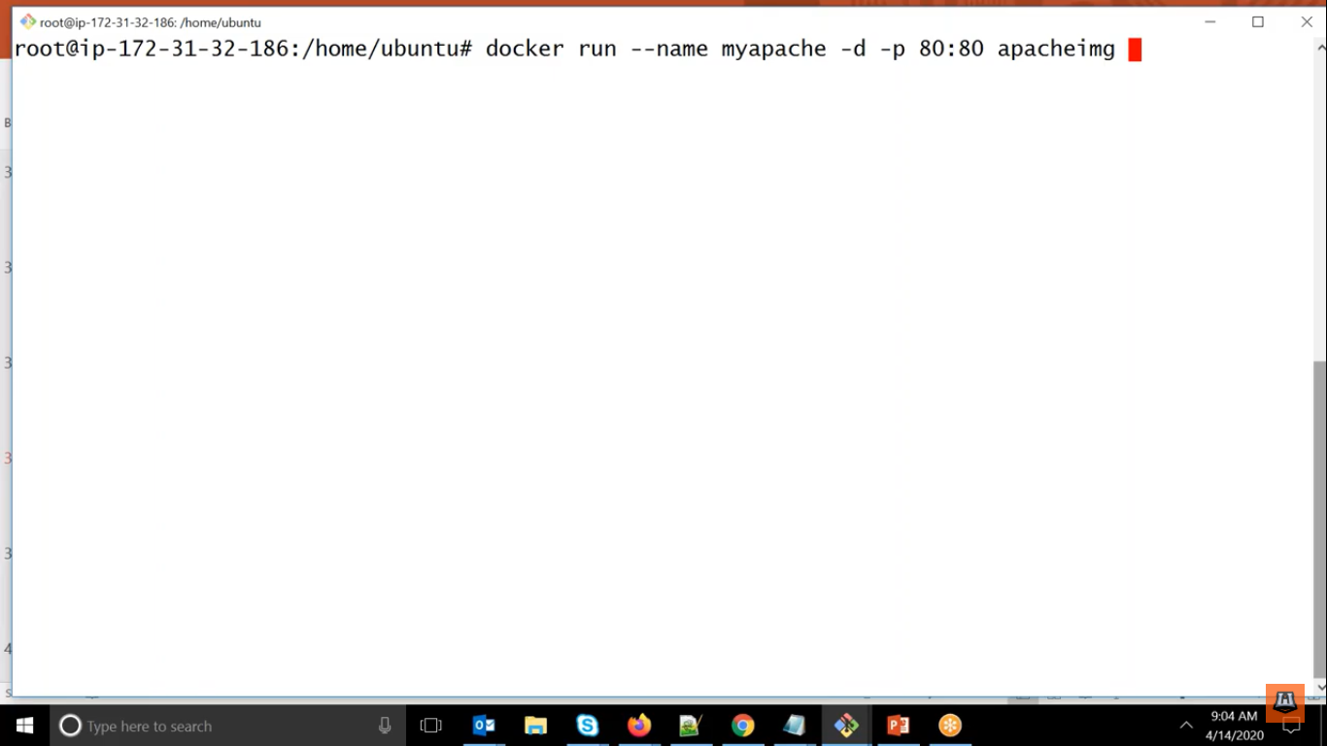

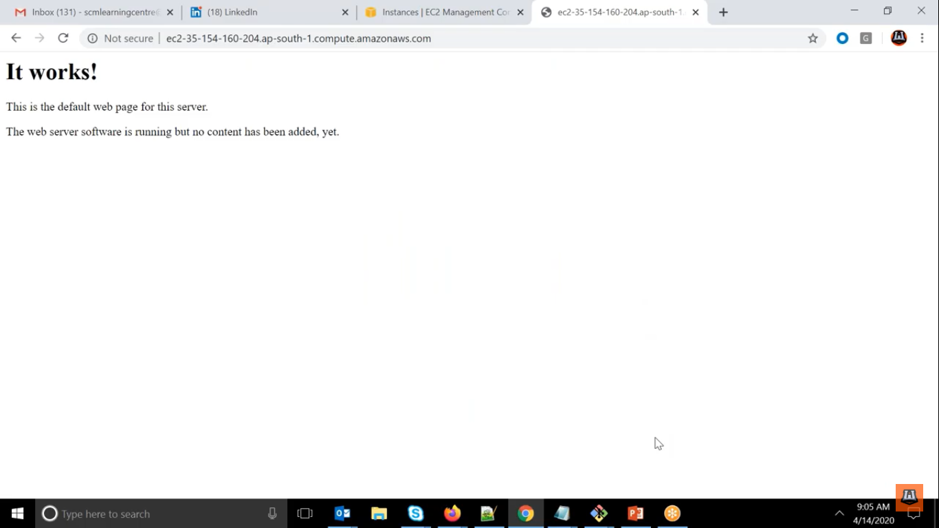

Tag

Here what we have observed that whenever we have created image but never given a tag to it

So everytime it is getting overridden with latest so if anyone is asking the 2nd last image we cannot give.

SO it is better to provide tag name always

<imageName>:<tag>

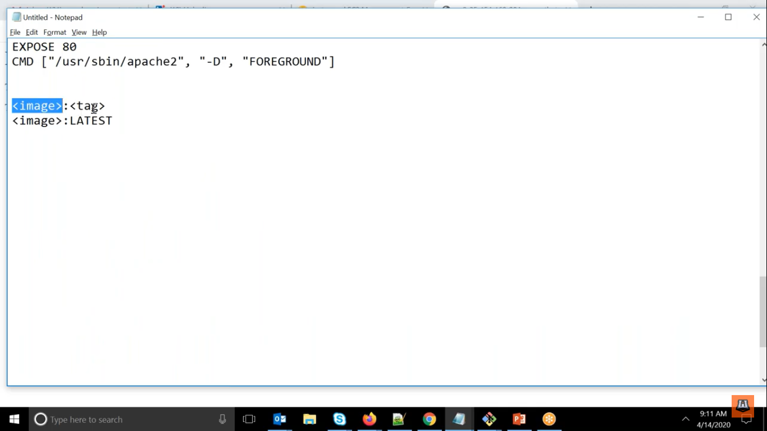

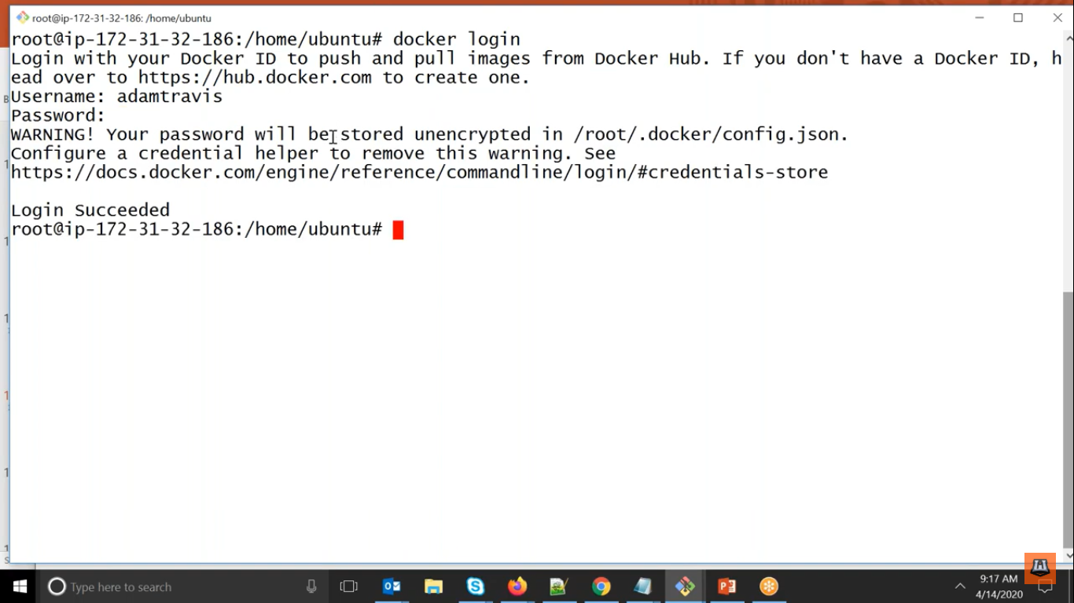

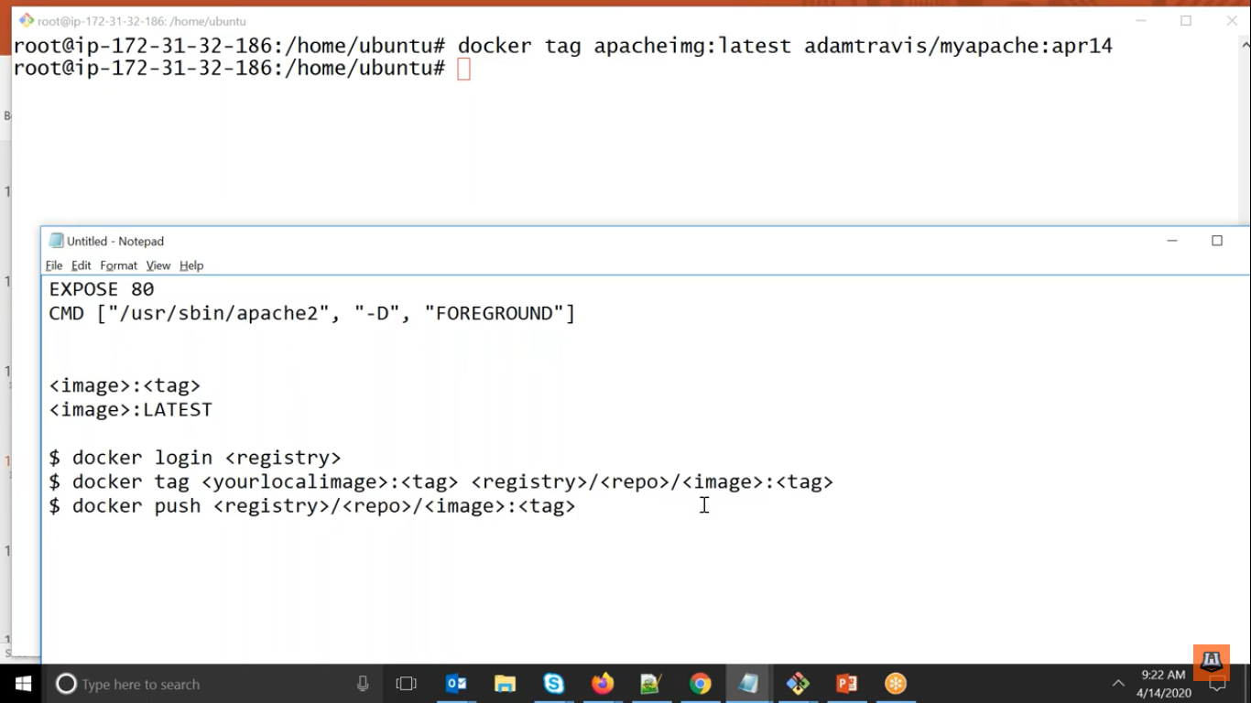

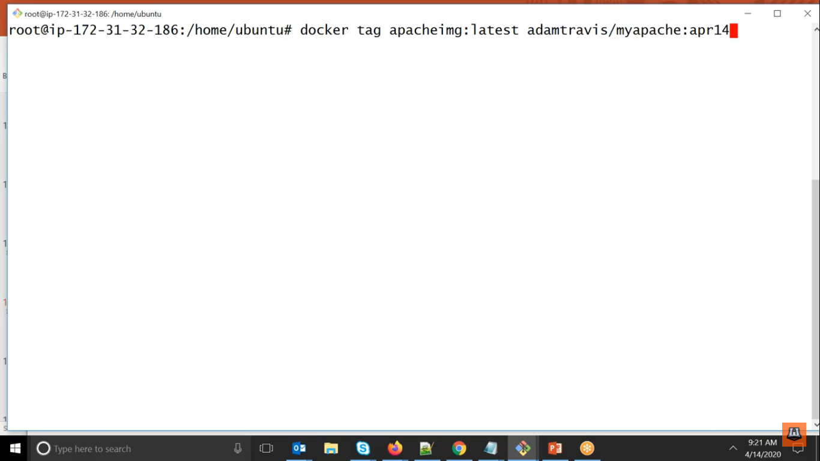

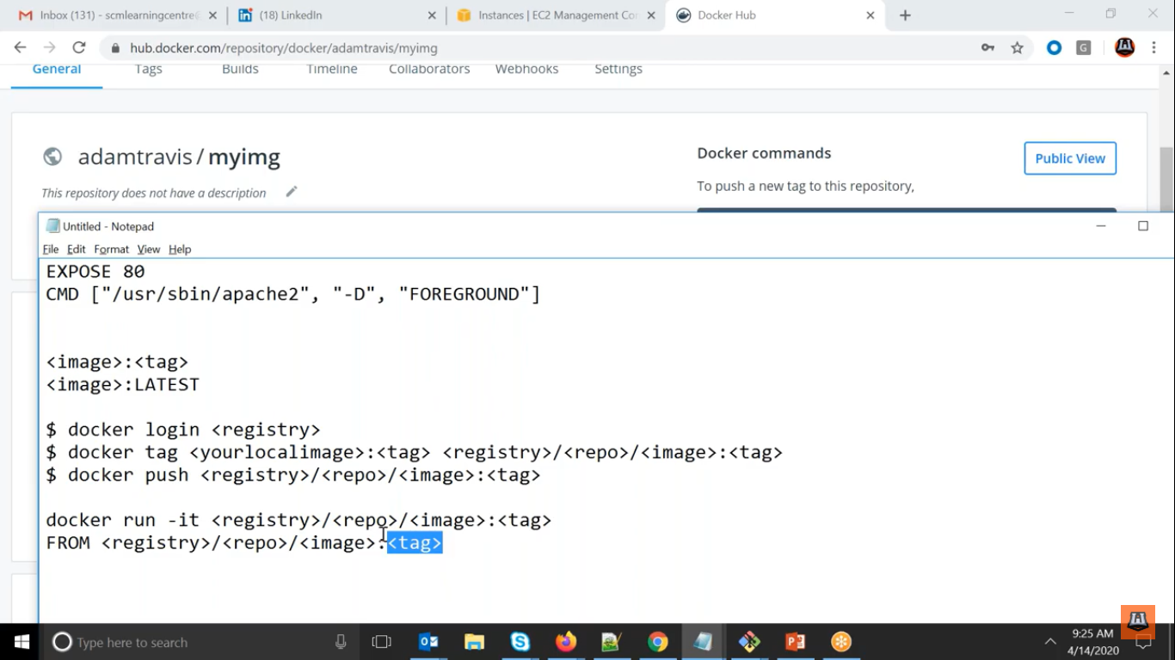

root@ip-172-31-45-217:/home/ubuntu# docker login

Login with your Docker ID to push and pull images from Docker Hub. If you don't have a Docker ID, head over to https://hub.docker.com to create one.

Username: pankaj3107

Password:

WARNING! Your password will be stored unencrypted in /root/.docker/config.json.

Configure a credential helper to remove this warning. See

https://docs.docker.com/engine/reference/commandline/login/#credentials-store

Login Succeeded

root@ip-172-31-45-217:/home/ubuntu# docker images

REPOSITORY TAG IMAGE ID CREATED SIZE

img002 latest f5cfa39265ef 44 minutes ago 215MB

<none> <none> b4bb8bb7adac 55 minutes ago 235MB

<none> <none> e24d8feec6c2 59 minutes ago 235MB

img001 latest 7e8290c80337 About an hour ago 215MB

<none> <none> 6bb84fc2bf47 About an hour ago 283MB

<none> <none> 571886f5b1f0 2 hours ago 283MB

testimg1 latest 3044b530b3ae 5 hours ago 235MB

centos latest 0d120b6ccaa8 25 hours ago 215MB

httpd latest a6ea92c35c43 5 days ago 166MB

nginx latest 08393e824c32 6 days ago 132MB

root@ip-172-31-45-217:/home/ubuntu# docker tag img002:latest pankaj3107/myimg:aug11

root@ip-172-31-45-217:/home/ubuntu# docker images

REPOSITORY TAG IMAGE ID CREATED SIZE

img002 latest f5cfa39265ef 50 minutes ago 215MB

pankaj3107/myimg aug11 f5cfa39265ef 50 minutes ago 215MB

<none> <none> b4bb8bb7adac About an hour ago 235MB

<none> <none> e24d8feec6c2 About an hour ago 235MB

img001 latest 7e8290c80337 About an hour ago 215MB

<none> <none> 6bb84fc2bf47 About an hour ago 283MB

<none> <none> 571886f5b1f0 2 hours ago 283MB

testimg1 latest 3044b530b3ae 5 hours ago 235MB

centos latest 0d120b6ccaa8 25 hours ago 215MB

httpd latest a6ea92c35c43 5 days ago 166MB

nginx latest 08393e824c32 6 days ago 132MB

root@ip-172-31-45-217:/home/ubuntu# docker push pankaj3107/myimg

The push refers to repository [docker.io/pankaj3107/myimg]

ad0c756bf436: Pushed

866de1ff2d0b: Pushed

291f6e44771a: Mounted from library/centos

aug11: digest: sha256:017e642b83c50cccb5cbeed75f8f6b72805454330d696925d0bf59ef82f95abe size: 942

root@ip-172-31-45-217:/home/ubuntu#

